RBI Tool (Super Admin) - Operations Manual


Oct 2023

Review Date | Reviewer Name | Version | Reference / Evidence
Document Revision History
Author | Date | Version | Description (Change made, Sec Ref, CR#)

Table of Contents
Definition of Terms, Acronyms, and Abbreviations 3
1. Super Admin Role Overview 4
2. Super Admin Module – Web Interface 4
3. General Instructions 13
3.1. Internet browser recommendations for optimum output 13
4. Support 14
4.1. Technical Support 14
5. Deployment Guidelines 15
5.1. RBI Tool Deployment Guidelines for NMRAs 15
Annexure-A 17
RBI Tool (GMP & GSDP) 17
Super Admin & NMRA level 17
Introduction 17

List of Appendices
Appendix # | Appendix Name | Page #

Definition of Terms, Acronyms, and Abbreviations
RBI Risk Based Inspection
GMP Good Manufacturing Practices
GSDP Good Storage & Distribution Practices
NMRA National Medicines Regulatory Authority
WHO World Health Organization

1. Super Admin Role Overview

The Super Admin role the top-level role inside the RBI Tool. This role is meant for a senior level user from the NMRA who is supposed to manage the following functions inside the RBI Tool:
- Change system mode from Normal mode to Maintenance mode where system is not available to users and once Super Admin will revert the mode to normal users will be able to access the RBI Tool as normal.
- Application Backup is another function to take application source code backup.
- Database Backup is very important where daily transactional data is backed-up by the Super Admin and in case of disaster, this back can be restored.
- Managing Permissions for various roles across the tool. It’s not recommended to change the already assigned permissions to various roles as they are already pre-defined in the tool as per role requirement.
- Approve and manage users inside the Tool.
- View users’ various activities in case of any audit-trail is required
- Define and manage RBI Tool Systems (GMP & GSDP)
- Define and manage RBI Tool System Level Elements (GMP & GSDP)
- Can create reference library that will be used by all system users.
- Can see and reply various technical queries

2. Super Admin Module – Web Interface
Left-Navigation Menu
Super Admin will login into the tool by using the login credentials. After successful login, Super Admin will have the following functions that are available on the left-navigation menu:
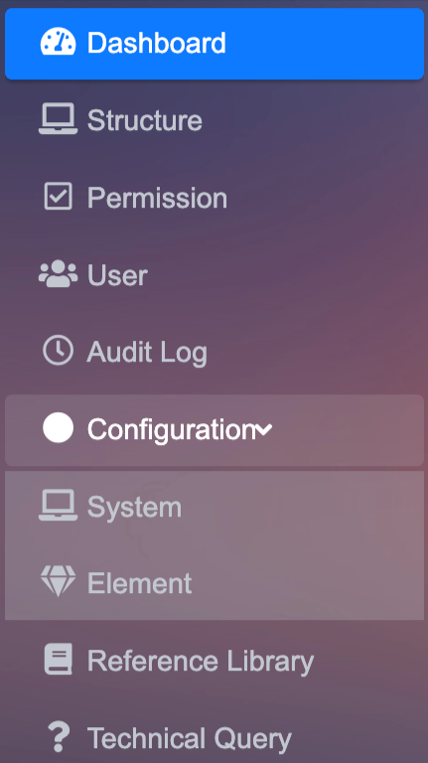
Figure – 1 – Super Admin - Functions’ List
Super Admin Dashboard
Super Admin Dashboard is the default view after successful login to the RBI Tool. This dashboard shows the functions in an iconic manner similar to the same available on the left-navigation menu.
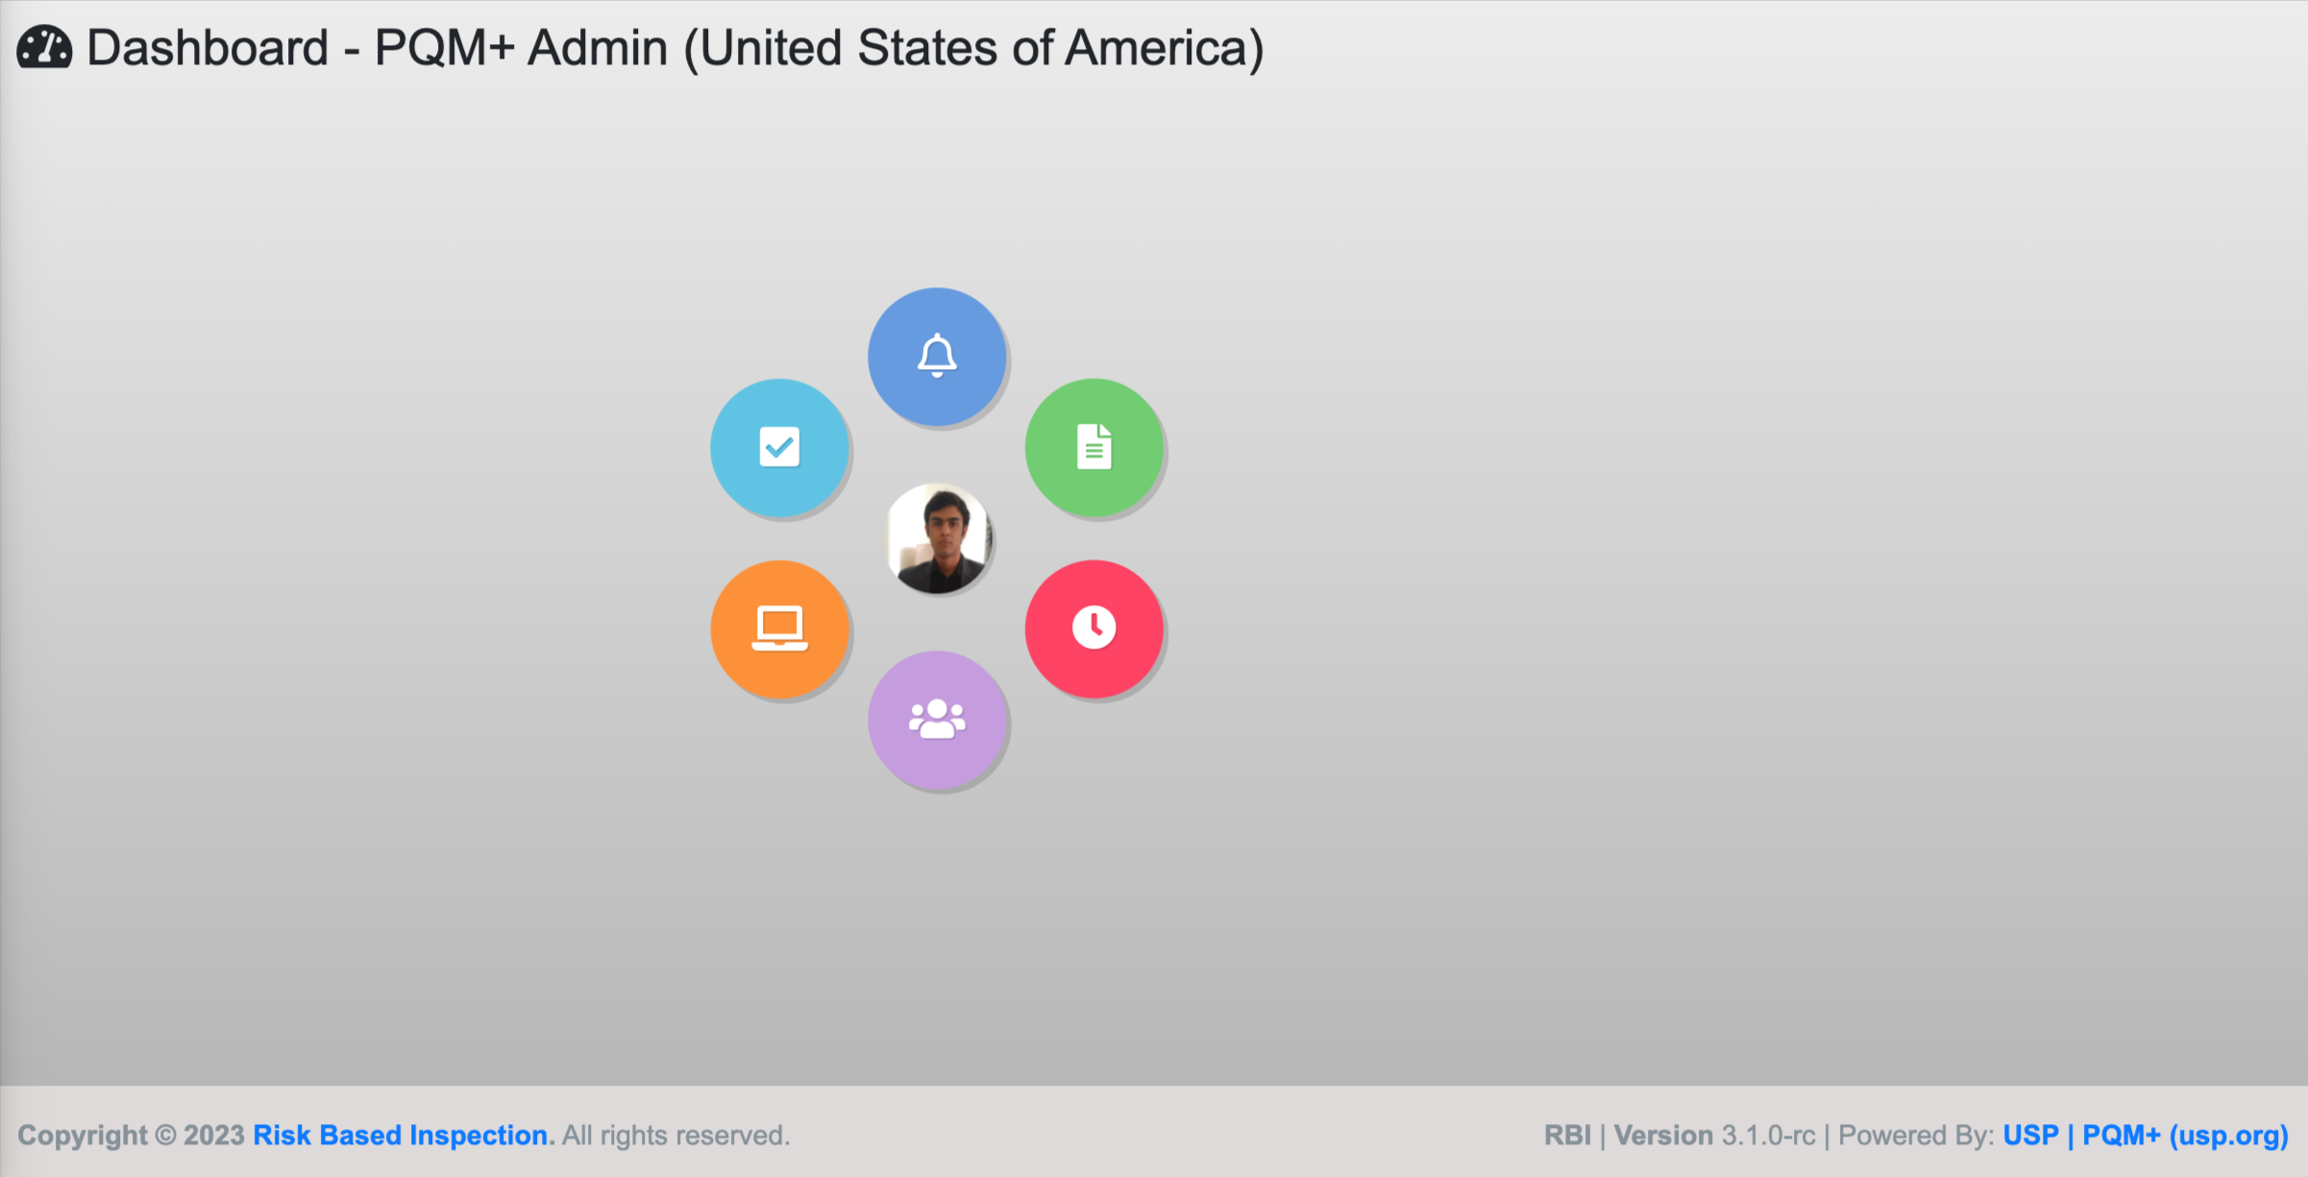
Figure – 2 – Super Admin Dashboard View

Structure
To access this feature, Super Admin will click on the Structure link form the Left-Navigation menu.
In this module Super Admin can perform the following tasks:
- System Mode: By default, system is in Active mode, meaning everyone can access it. If there are any updates in the RBI system, Super Admin can change the System Status from Active to Maintenance. If mode is set to Maintenance, no user can access the system till the time, system mode is set back to Active.
- Database Backup: Super Admin can take RBI Database backup. This back will be stored under the backup folder in the root project folder. This backup is normally taken to save the daily working of the NMRA staff on various activities, like scheduling, execution of various inspections and other related activities inside the tool. If at any point and time, RBI Tool hosting server is crashed, Super Admin will have the database backup to restore it back to the point when the last backup was taken.
- Application Backup: Super Admin can also take the backup of the software itself that will be stored in the same backup folder as stated above. Like the Database backup, the application backup is normally taken to save the RBI software source code /application tool. If at any point and time, RBI Tool hosting server is crashed, Super Admin will have the Application source code backup to restore it back to the server to make it available for other users to access the software as normal.

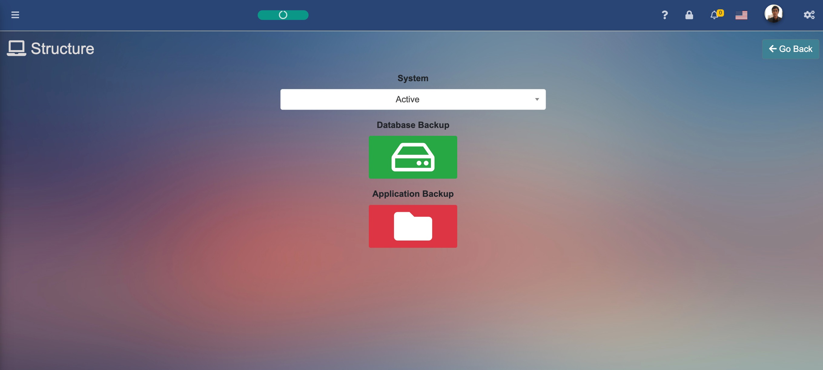
Figure – 3 – Structure
Permission
To access this feature, Super Admin will click on the Permission link form the Left-Navigation menu.
In this module Super Admin can grant /revoke the permissions to the pre-defined user roles as shown below and after editing the role, Super Admin can grant /revoke specific permission against specific module /interface as shown below:
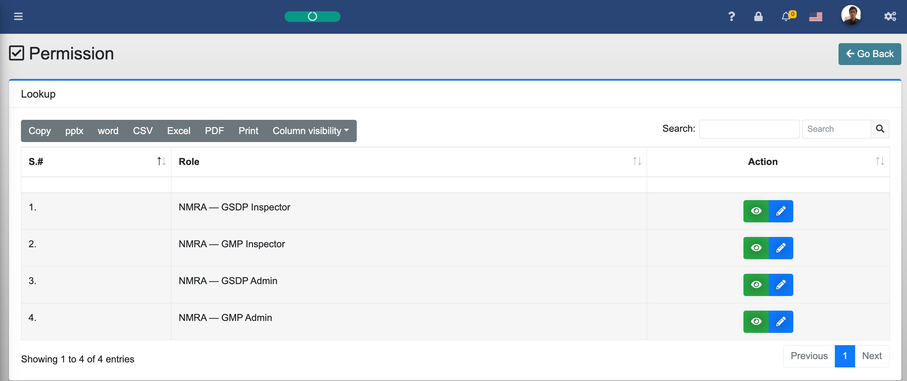
Figure – 4 – Permission

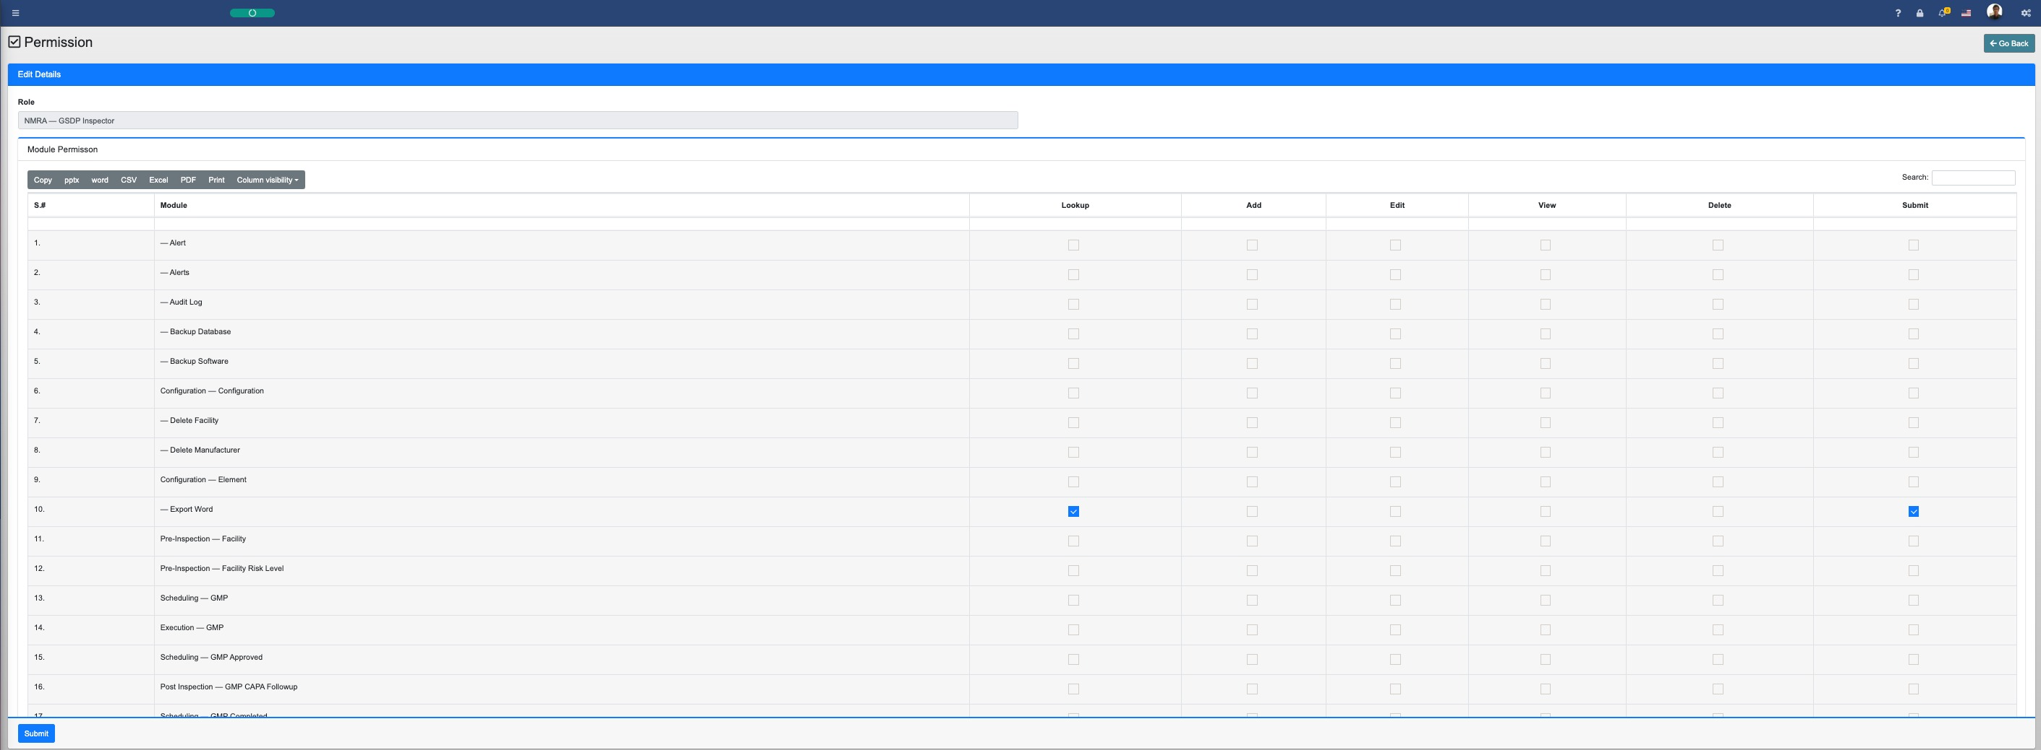
Figure – 4.1 – Permission
P.S. Please be advised not to change any permission against any role as they are pre-defined in the tool as per the expected role requirements.
User
To access this feature, Super Admin will click on the User link form the Left-Navigation menu.
In this module Super Admin can approve the NMRA Admin (GMP) or NMRA Admin (GSDP) user account request. Ideally one NMRA may have one GMP Admin and One GSDP Admin accounts accordingly that will be applied via registration form. Super Admin will edit the user and will Approve the NMRA Admin user who will then get an email with login credentials. Please see below user interface for the same:

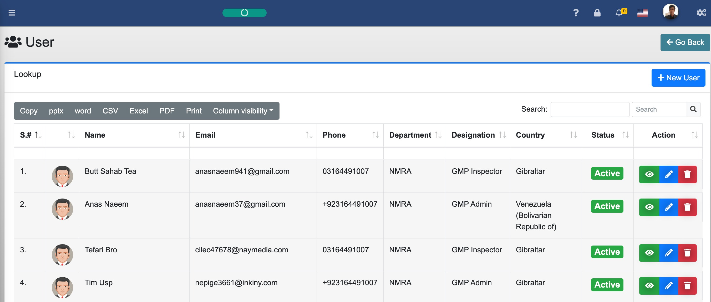
Figure – 5 – User

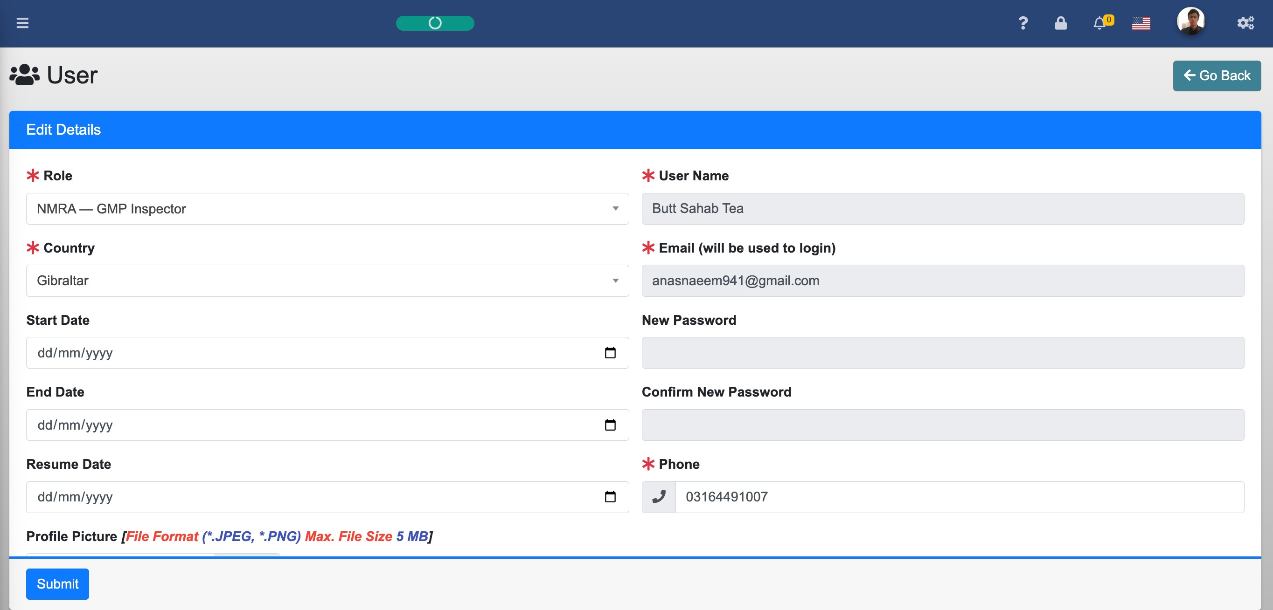
Figure – 5.1 – User
Audit Log
To access this feature, Super Admin will click on the Audit Log link form the Left-Navigation menu.
In this module Super Admin can view the different activities that have been logged at the back-end of the software, like login, logout time, Updating any data, etc. Super Admin can see the details of various actions as per below figures:

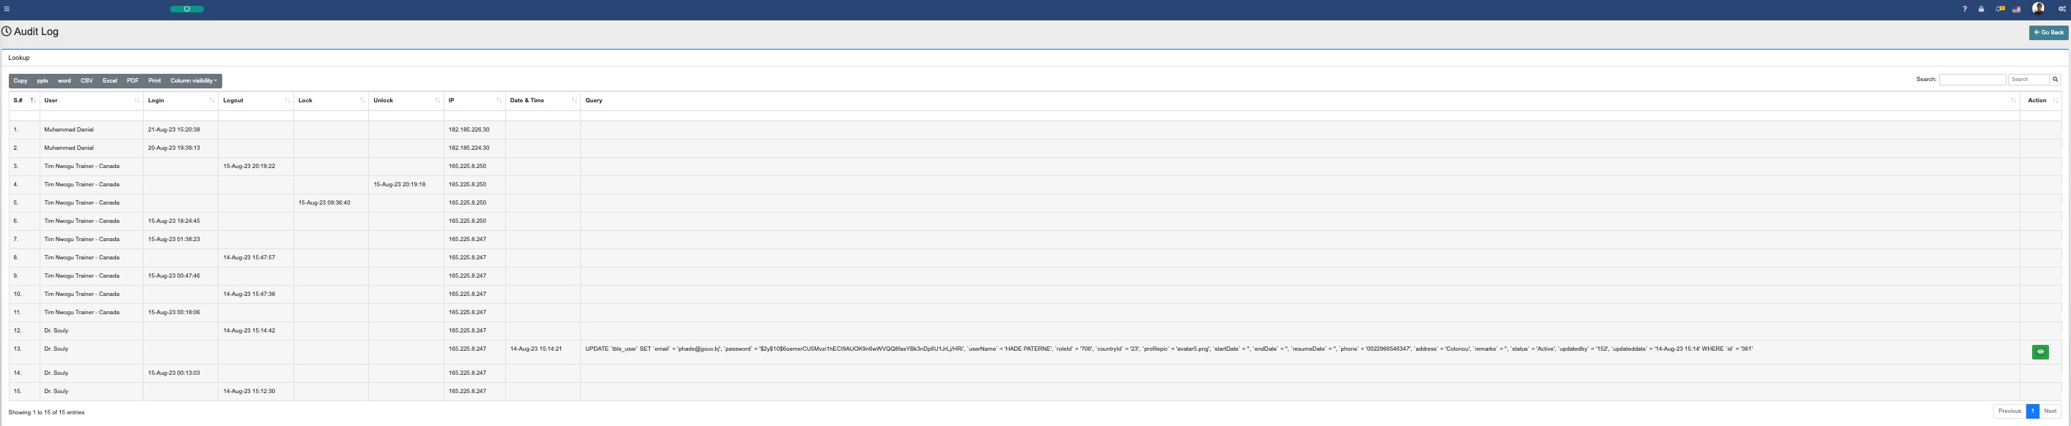
Figure – 6 – Audit Log

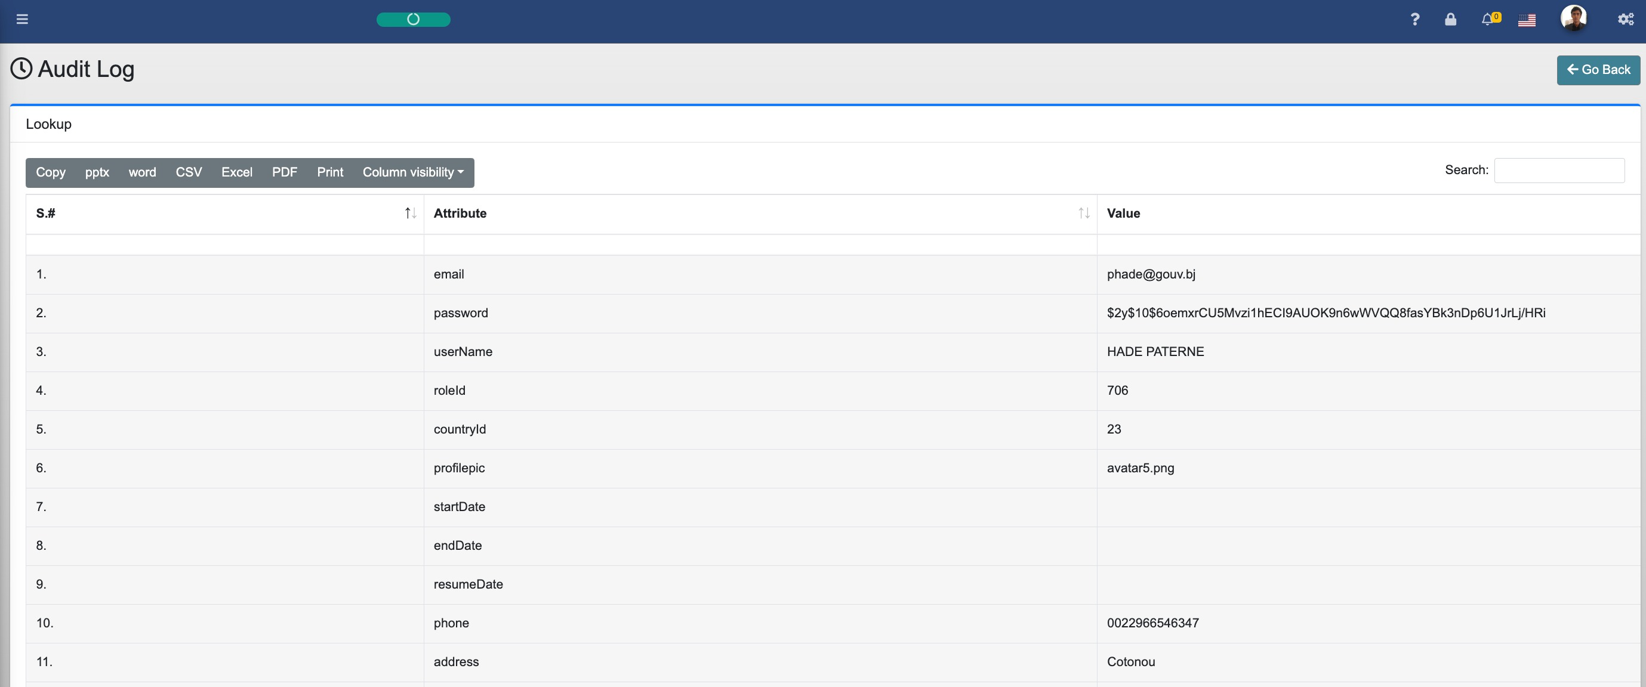
Figure – 6.1 – Audit Log

Configuration Systems
To access this feature, Super Admin will click on the Configuration and then click on System link from the Left-Navigation menu.
Super Admin has rights to Add /Edit /View all pre-defined Systems related to GMP or GSDP in the RBI Tool. Following user interface will be displayed to user:
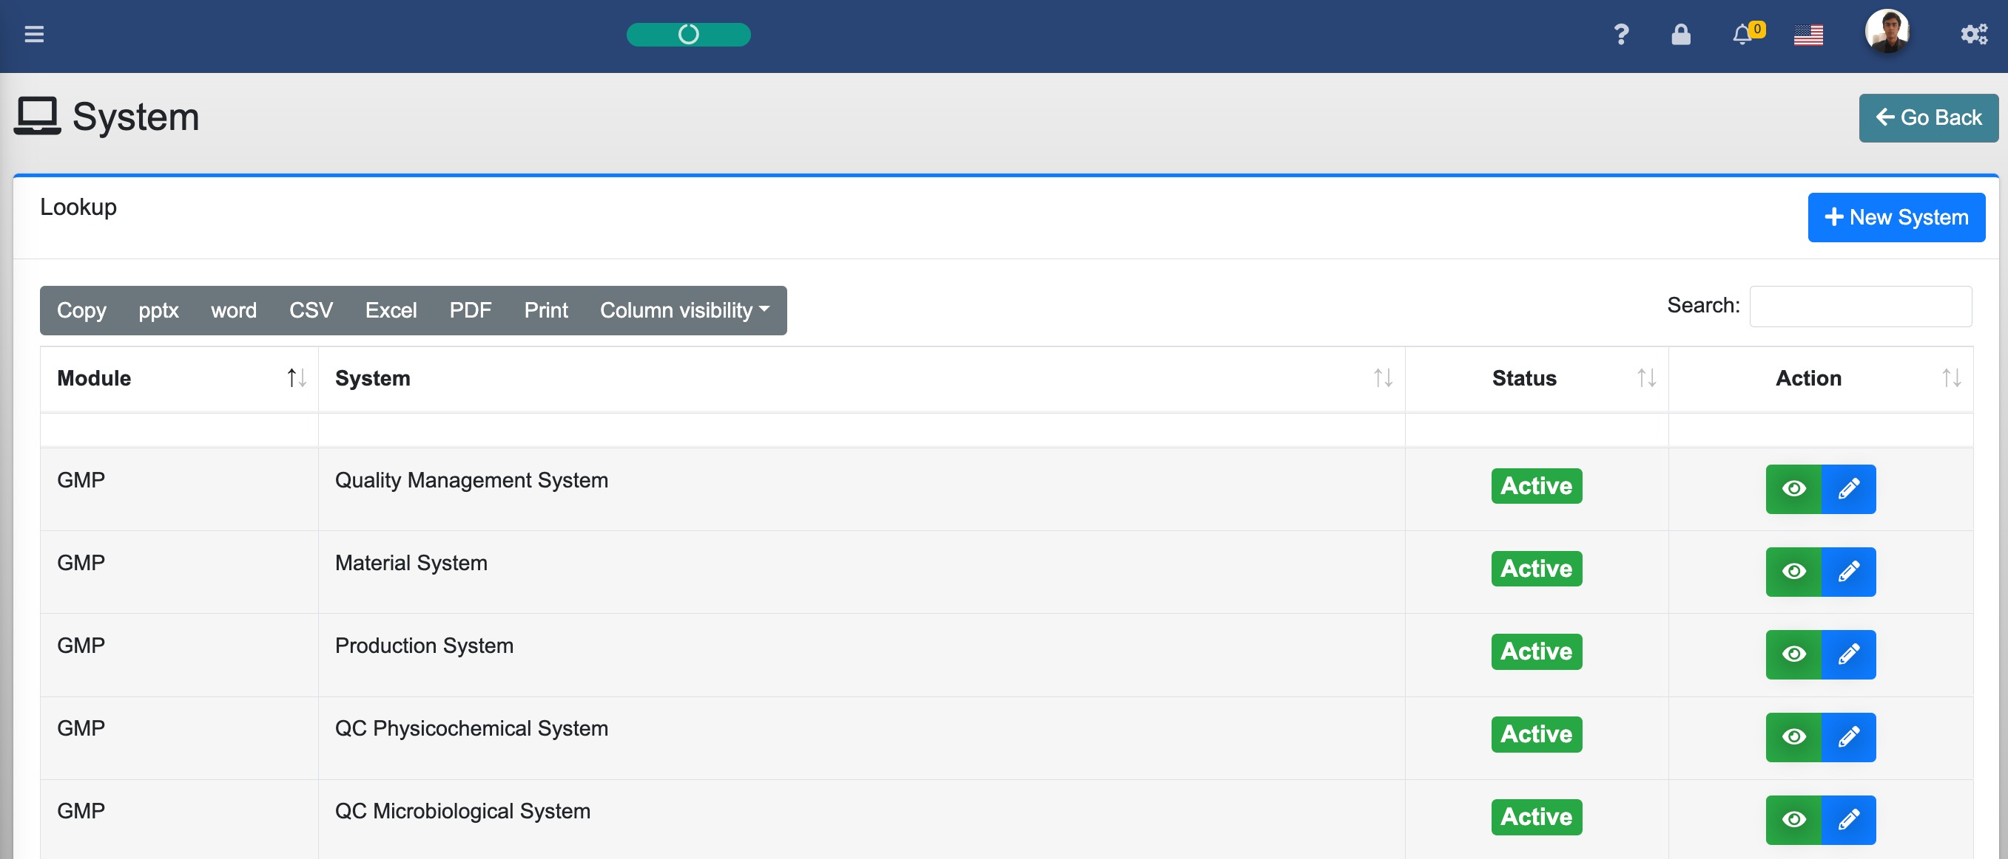
Figure – 7 – List of Systems (GMP & GSDP)

Super Admin defines these GMP & GSDP related RBI Systems that will be available to respective NMRA Admin and Inspectors to use while scheduling and executing the inspections.

Configuration Elements
Super Admin can also Add /Edit /View the System Elements that will also show the Element wise Risk Rating in the view. To access this interface, from the left-navigation menu, user will click on Configuration and then will click on Element sub menu and following interface will be displayed to the user:
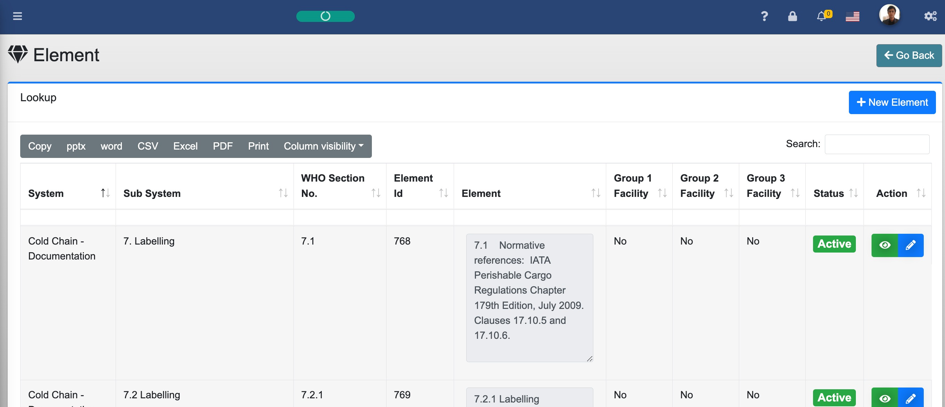
Figure – 8 – List of Pre-defined System Elements & Risk Rating
Once the GMP & GSDP systems are defined, Super Admin can now define or manage the respective elemenets of the respective RBI System. User can either create new Element of the desired system or can edit the existing system element as the case may be.
P.S. Please note that in GSDP elements, they are further divided into three groups, like Group-1, Group-2 and Group-3 facilities for better management and identification of each facility type and Super Admin can define it as default value whether this particular elemenet is relevant to the respective element group or not. If this element is related to that group and same group facility is chosen for the inspection then this particular element will be there as default element for the inspection assessment of that particular system.
Reference Library
To access Reference Library, from the left-navigation menu, click on Reference Library menu and following interface will be displayed:
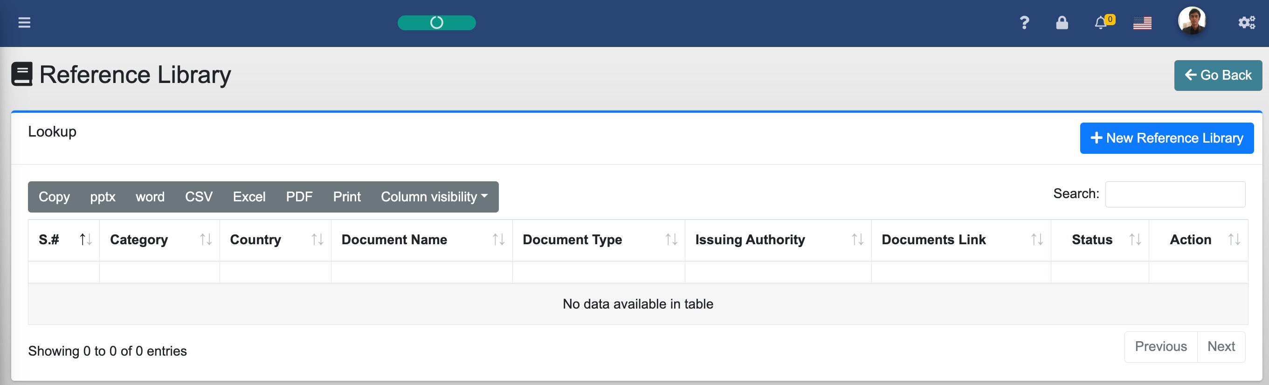
Figure – 9 – List of Reference Library
To add New Reference Library, user will click on + New Reference Library button on top-right of the lookup interface:
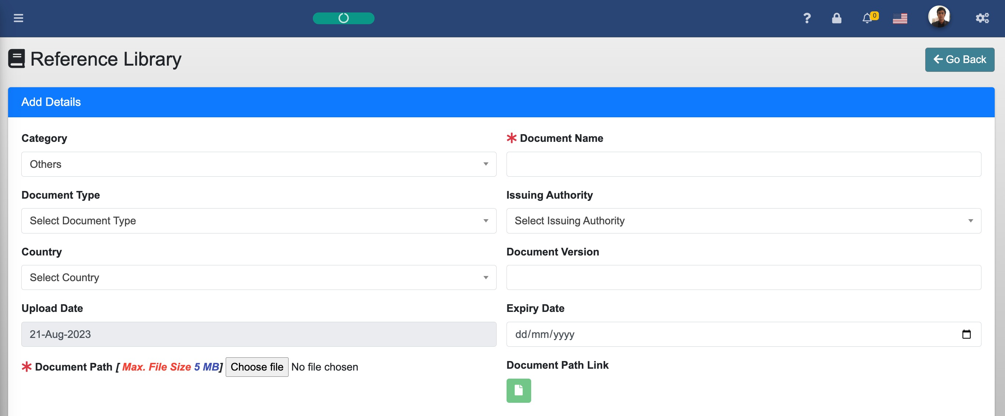
Figure – 9.1 – Add /Edit List of Reference Library
Reference library is a repository of technical documents that is made available to all system level users to better understand the various aspects of the RBI System and various best practices and standards being used across the world.

3. General Instructions

3.1. Internet browser recommendations for optimum output

Please consider the following general instructions for the optimum utilization of the RBI Tool:
- For best look and feel of the RBI Tool, please use the following latest web browsers:
  - Google Chrome
  - Microsoft Edge
  - Firefox Mozilla
  - Safari
  - Opera

4. Support

4.1. Technical Support

For any technical support related to RBI Tool, user can contact the under-signed:
PQM+
Call:1-800-227-8772, +1-301-881-0666, or 00-800-4875-5555
Email: pqm@usp.org

5. Deployment Guidelines

5.1. RBI Tool Deployment Guidelines for NMRAs

RBI Tool Deployment - Pre-requisite
- Server-Side Hardware Requirements
  - Xeon™ based server family processors (new generation) with 32 GB of RAM
- Server-Side Software Requirement
  - CentOS operating System (Recommended)
  - SSL Certificates
  - Apache
  - MariaDB
  - PHP
- Server-Side Configuration
  - Configuration of the server-side components to manage the transactions and users’ workload
- Application-Side Requirement
  - Creation of the RBI Tool Package for the NMRAs to download and deploy the application as per technical specifications.
- Internet Connection
  - Good Internet connection to support the load of users and transactions accordingly.
- Technical Assistance
  - Since, this deployment is a technical job, there must be a technical team to support this deployment in the respective NMRA.
- RBI Tool Training
  - Need to provide the training of the tool to the concerned staff who should be considered as master trainer to conduct their future trainings as needed.
- Mobile App (Offline Inspection Tool)
  - Can be downloaded from Google Play Store and configured by the respective NMRA to be used in the field for the execution of the inspection.

RBI Tool Deployment – Steps
Step-1
- Download the RBI Tool application from the link provided by USP-PQMPlus Team
- Unzip the RBI Tool downloaded file
- As per above-mentioned hardware and software infrastructure, copy the root folder (e.g., rbi-prod) under the main public web folder like public_html, etc. of the Apache web server directory.
Step-2
- Create a new database in MySQL /MariaDB and name it like rbi-prod
- Create a new user and link it with the newly created database file along-with appropriate rights.
- Restore the RBI Database Backup file (rbi.sql) in the newly created database

Step-3
- Configure the /application/config/database.php file that should reflect the database name, user name, password and related variables.
- Configure the email settings in the /application/helpers/cias_helper.php

Once, this is all set, you are good to launch the RBI Tool on a web browser by giving the appropriate address to access the login page like, https://pqmplustools.com/rbi-training

Annexure-A

RBI Tool (GMP & GSDP)
Troubleshooting guide

Super Admin & NMRA level

Introduction
This troubleshooting guide will be used by the Super Administrator of the RBI Tool during a scenario where the Super Admin might be stuck for further processing. This guide will be considered as Knowledge-Base (KB) document as well for certain issues that may pop-up during the execution of the Super Admin functions. Super Admin can search by keywords for scenario of the relevant issue.
All possible scenarios are mentioned below to see the proper solution of the issue they are facing with:
- Email Failure: System is not sending emails against various triggering points, like:
- New account credentials to the user
- Password reset emails (I forgot my password)
- Inspection Assignment
- Inspection Agenda to Company
- CAPA email to company, etc.
REASON: Email configurations are not set properly on the server side.
Steps to follow: Super Admin will follow these steps:
- Step-1: Check the SMTP email settings in the following file:
  - application/helpers/cias_helper.php
- Step-2: Make sure this file has proper smtp settings as per your current environment and sample settings are shown below:
==========================================

if(!function_exists('setProtocol'))
{
function setProtocol()
{
$CI = &get_instance();

$CI->load->library('email');

$config['protocol'] = 'smtp'; // smtp
//$config['mailpath'] = '/usr/sbin/sendmail'; //

// final working
$config['smtp_host'] = theServer;
$config['smtp_port'] = '587';
$config['smtp_user'] = theEmail;
$config['smtp_pass'] = 'thePassword;
$config['smtp_auth'] = TRUE;
$config['smtp_crypto'] = 'no';
// final working

//$config['timeout'] = '7';
//$config['smtp_crypto'] = 'ssl';
$config['charset'] = 'UTF-8';
$config['mailtype'] = 'html';
$config['newline'] = "\r\n";

$CI->email->initialize($config);

return $CI;
}
}
==========================================

- RBI Landing Page Errors: After entering the RBI URL, the landing page is not shown properly and shows an error message like below figure:
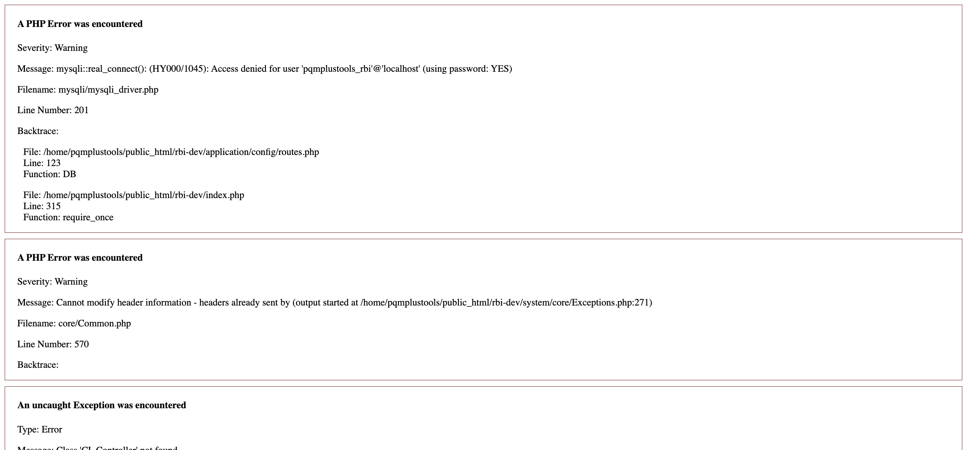
REASON: Database configurations are set properly on the server side.
Steps to follow: Super Admin will follow these steps:
- Step-1: Check the Database settings in the following file:
  - application/config/database.php
- Step-2: Make sure this file has proper database settings as per your current environment and sample settings are shown below:
==========================================$db['default'] = array(
'dsn' => '',
'hostname' => 'localhost',
'username' => 'TheDBUserName',
'password' => 'TheDBUserPassword',
'database' => 'TheDatabaseName',
'dbdriver' => 'mysqli',
'dbprefix' => '',
'pconnect' => FALSE,
'db_debug' => (ENVIRONMENT !== 'production'),
'cache_on' => FALSE,
'cachedir' => '',
'char_set' => 'utf8',
'dbcollat' => 'utf8_general_ci',
'swap_pre' => '',
'encrypt' => FALSE,
'compress' => FALSE,
'stricton' => FALSE,
'failover' => array(),
'save_queries' => TRUE
);
==========================================

- RBI TOOL Maintenance Mode: When Super Admin change the RBI Tool Status from Active to Maintenance then no user can access the tool until or unless status is not set back to Active by the Super Admin. Following landing page will be displayed to the user where email and password fields are not visible and an animation of configuration icon will be there:
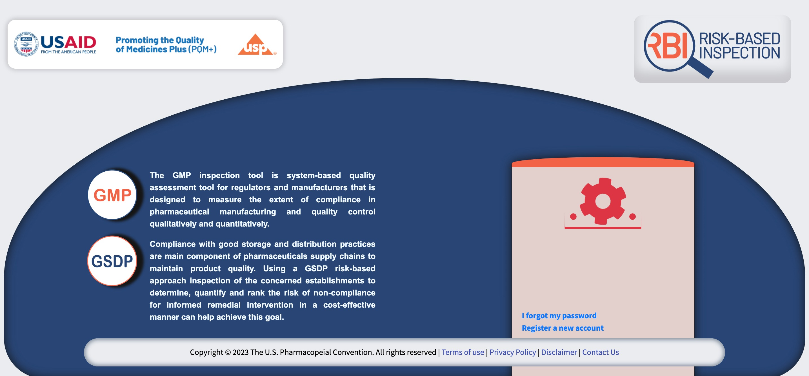
REASON: Super Admin has set the RBI Tool under Maintenance mode to perform system-level maintenance related activities.
Steps to follow: Super Admin will follow these steps:
- Step-1: Login to MySQL /MariaDB on the server
- Step-2: Select the RBI database
- Step-3: Open tbls_System table
- Step-4: Change Status against column Mode with value of Maintenance from Active to Inactive of the second row and save the record as shown below:
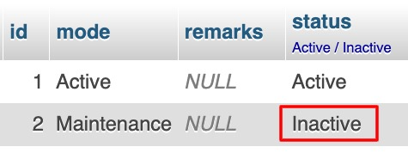
- Step-5: Now refresh the RBI page and it will load the landing page as normal.

- After login, always default profile page is displayed: Whenever user logs-in the RBI Tool since it’s creation, user always observes the profile page after the login. Why it doesn’t go directly to the Dashboard page of the RBI Tool.
REASON: Since user hasn’t changed his/her password after the first login with the system generated password, RBI Tool always opens the profile page to remind the user to change the password. Once password is changed, user will not see this profile page after login. However, user can change his /her password on any stage by clicking on the profile page as described in the user operational manual.

Steps to follow: User will follow these steps:
- Step-1: From the profile page, input following information:
  - Old Password
  - New Password
  - Confirm New Password
- Step-2: Click on Submit button to save the profile
- Step-3: Next time when you will login to the RBI Tool, you will not see profile page after successful login until or unless you open profile page by yourself.

- What Super Admin should do in Case of disaster & recovery scenario: It’s always recommended to take database backup of the RBI Tool on daily basis as described in the user operational manual. However, application backup should also be taken if there were any modification made in the functionality of the RBI Tool itself. Backup functionality procedure is provided in the System Administrator role as prescribed in the user operational manual.

REASON: Sometime server’s operating system is corrupted because of various reasons, like some virus attach, malware software related activities or by the negligence of the server administrator or because of some natural disaster that corrupts the server of even the database as well. In this case, software will not work as desired.

Steps to follow: User will follow these steps:
- Step-1: Download the latest Application and database Backup files from the following folder:
  - backup
- Step-2: Normally you will see following types of files:
  - RBI_03-Oct-23 23-11-52.zip – (This is application Backup file)
  - RBI_14-Sep-23 00-19-14.gz – (This is database Backup file)
- Step-3: Use these updated files to deploy the RBI Tool application as per the steps provided in the operation manual (deployment section).

