Risk-Based Inspection Tool - Operations Manual: (GMP & GSDP)


Oct 2023

Document Information
Category | Information
Document Owner | The U.S. Pharmacopeial Convention - PQM+ Program
Document Name | RBI Tool–Operations Manual: GMP and GSDP Module
Document Version
Identifier | PQM+ - RBI Tool Operations Manual
Author(s) | PQM+
Approver(s) | PQM+
Issue Date
Distribution | All subscribers
Document Revision History
Author | Date | Version

Table of Contents
Acronyms 3
Background 6
The GMP Module User Level 7
Getting Started 8
Modules of RBI Tool 8
Graphical User Interfaces (GUI) 9
Getting Familiarized with the Tool Interfaces 9
GMP Inspection Module – Web 14
GMP Inspection Module – Mobile Interface 23
NMRA GMP Inspector 23
GSDP Inspection Module – Web 41
NMRA GSDP Admin 41
NMRA GSDP Inspector – Web 54
General Instructions 63
Internet browser recommendations for optimum output 63
Support 64
Technical Support 64
Annexure-A 65
Introduction 65

Acronyms
CSV Comma-Separated Values /Coma Delimited Values
GUI Graphical User Interface
GMP Good Manufacturing Practices
GSDP Good Storage & Distribution Practices
NMRAs National Medicines Regulatory Authorities
PQM+ Promoting the Quality of Medicines Plus Program
RBI Risk Based Inspection
SA Super Administrator
USP United State Pharmacopeia

Definition
Archiving. the process of long-term storage and protection of records in the RBI tool from the possibility of deterioration, and being altered or deleted, throughout the required retention period defined by the user.
Audit trail. the audit trail is a form of metadata containing information associated with actions that relate to the creation, modification or deletion of GMP/GSDP records in the RBI tool.
Backup. the copying of records from the RBI tool at defined intervals, in a secure manner to ensure that the data are available for restoration.
Data. All original records and true copies of original records, including source data and metadata, and all subsequent transformations and reports of these data which are generated or recorded at the time of the assessment using the RBI tool.
Graphical User Interfaces (GUI): a user interface that allows a computer user to interact easily with the computer typically by making choices from displayed menus or groups of icons.
Inspector: formally designated person to produce a statement of fact on behalf of the NMRAs based on inspection and assessment of observations by objective evidence.
Metadata. Metadata are data that provide the contextual information required to understand other data. These include structural and descriptive metadata, which describe the structure, data elements, interrelationships and other characteristics of data that also permit data to be attributable to an individual performing the assessment or recording of the activity.
Modules: This refers to the package of independently operable systems of the GMP and GSDP module presented as an electronic component of the RBI tool.
User: the designated individual or organization with purposely defined privileges who uses the RBI tool.
User interface: software that is designed to allow a computer user to interact with the operating system of a machine or system (such as by selecting presented options or entering text commands).
RBI Tool: a computer program that is designed to convert the given selected inputs of the GMP and/or GSDP modules in a form of elements to provide as an output in a form of qualitative and quantitative scoring and assessment reports.
NMRA Administrator: designated senior NMRA personnel who is responsible to create inspectors pool and manufacturers database for scheduling of inspections.
Super Administrator: the top-level user responsible for configuration of the tool interface including creation of the lower-level user privilege: NMRA Administrator and inspector
Reference Library. The reference library is a repository of regulatory guidance documents adopted and/or issued by NMRAs to enforce regulatory inspection process.
Technical Query. In case of any technical assistance is required, initiator can send a technical query to the authorized person who will respond back to the initiator with the required assistance or solution.
Reports. Documents generated as an output using the RBI tool; for example, GMP assessment report.

Background
The RBI Tool is a web-based software that is designed using the open-source technologies like PHP-Based framework (CodeIgniter), MariaDB /MySQL database and Apache webserver. In an open-source technology, like PHP and other related technologies, source code is available to the end-users (like NMRA) to further modify the tool as per their requirements and needs. Furthermore, this tool can be used offline (to be used within the office premises) or can be used from anywhere provided you have a proper device and a stable internet connection. The software tool can also be used on a cellular device. There’s an Android based mobile app that can be downloaded from the Google Application store and can be used in an online and an offline environment. Details can be found in the respective section of the user guide.

The RBI Tool is an online software application designed for NMRAs Administrator and Inspectors to schedule and execute GMP & GSDP inspections as per industry best practices. This tool is designed on role-based where each and every user of the tool is assigned sufficient privileges to perform their respective tasks as desired by the NMRA. The tool’s User interfaces are designed in such a way that it reflects similar look and feel across all user interfaces for the user to be more comfortable when using various interfaces of the tool.

Internet browser recommendations for optimum output

Please consider the following general instructions for the optimum utilization of the RBI Tool:
- For best look and feel of the RBI Tool, please use the following latest web browsers:
  - Google Chrome
  - Microsoft Edge
  - Firefox Mozilla
  - Safari
  - Opera
- Reasonable internet speed to host this application for the NMRA routine operation and it’s to be determined by NMRA IT staff.

Access, Account creation, and Security
Access to the latest version of the RBI Tool link will be published and made available at the following address [https://pqmplustools.com]. To access the tool, as super administrator, the user must be a designated responsible person representing the NMRAs. Once the user is on the landing page, request to access the tool via the landing page must be sent to the owner of the tool, Super Admin or designated person.
When NMRA will have the RBI Tool ready, the NMRA Admin can register using the Register a new account link on the landing page of the RBI Tool. After registration request is made, the Super Admin can review the registration request of the of the NMRA Admin and Super Admin will then approve the request and login credentials will be sent to NMRA Admin provided email.
When NMRA Admin is active he/she can further create NMRA inspectors by creating the Panel Pool. The inspector who will be with inspector role will get an email credentials on the inspector’s email. This will allow inspector to login in the RBI Tool as a Lead Inspector role who’s supposed to conduct the inspections.
The data of the NMRA is stored in a secure environment where it can only be accessible to the authorized personnel who are supposed to manage the data as per NMRA needs and requirements. Other than this data storage, an option inside the tool is also given where Super Admin can take daily data backups to place them in a secure environment that can be used in case of backup restoration, if required ever.

The GMP Module User Level
The GMP RBI module is structured into three user levels:

- Super Administrator
The Super Administrator is the top-level user of the tool who is responsible to:
  - Create /Approve NMRA Admin
  - Create and update the tool systems and elements level configuration.
  - Manage the meta-data that will be used in the RBI Tool
  - Respond to the technical queries from NMRA Administrator
Further details on the super administrator roles and responsibilities are available in manual for the SA that is issued separately.
- NMRA GMP Administrator
- The NMRA GMP Administrator is the country level Admin authorized by super administrator who is responsible for
  - View the RBI Systems and Elements and related information
  - Create Manufacturers database and inspection panel pool members
  - Schedule a GMP Inspection
  - View inspection dashboards
  - Approve inspection schedule and change to inspection status and monitor inspection progress
  - Send technical queries to Super Admin and respond to the technical queries from GMP inspector
  - Generate historical and current inspection report to create NMRA’s inspection performance report.
  - Upload inspection related guidance documents to the library

- NMRA GMP Inspector
The NMRA GMP Inspector is the person designated as GMP Inspector by the NMRA administrator and is responsible for
  - Plan to execute the assigned GMP Inspections
  - Prepare and send inspection Agenda to the company
  - Execute inspection agenda and conduct the risk-based GMP assessment
  - Prepare Inspection Report
  - Prepare CAPA Report & Follow-up
  - Send technical queries to NMRA Admin
  - Create historical and current data reports

- NMRA GSDP Administrator
The NMRA Administrator is the country level Admin user who can
  - View the RBI Systems and Elements and related information
  - Create Facilities database and inspection panel pool members
  - Schedule a GSDP Inspection
  - View inspection dashboards
  - Approve inspection schedule and change to inspection status and monitor inspection progress
  - Send technical queries to Super Admin and respond to the technical queries from GSDP inspector
  - Generate historical and current inspection report to create NMRA’s inspection performance report.
  - Upload inspection related guidance documents to the library

- NMRA GSDP Inspector
The NMRA GSDP Inspector is the country level GSDP Inspector user who can
  - Plan to execute the assigned GSDP Inspections
  - Prepare and send inspection Agenda to the company
  - Execute inspection agenda and conduct the risk-based GSDP assessment
  - Prepare Inspection Report
  - Prepare CAPA Report & Follow-up
  - Send technical queries to NMRA Admin

Getting Started
This section describes on how many modules are there in the RBI Tool and how to actually use the core software modules of the RBI Tool. This section will also demonstrate various GUIs that are applicable throughout the system and main purpose of this section is to facilitate users in understanding the various functions /options that are available to the users.

Modules of RBI Tool
- GMP
- GSDP

Graphical User Interfaces (GUI)

Getting Familiarized with the Tool Interfaces

Landing Page
After entering the web address for RBI Tool URL, provided by NMRA Super Admin, the following landing page will be displayed to user:
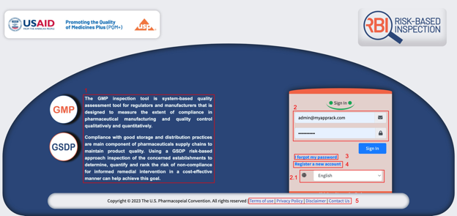
Figure 1: RBI Tool Landing Page

The landing page contains the following tabs:
- GMP & GSDP module with brief description
- Login credential input fields
- Forgot password reset tab
- New NMRA Admin registration tab
- Link to the following information for the user:
  - Terms of Use
  - Privacy Policy
  - Disclaimer
  - Contact Us

The user must click on respective tab to access the detail information in the respective document and need to read and agree to the terms of agreement to access the tool.
The user can also click on the Contact Us link to send technical queries to the t RBI Support team.

To register a new account on behalf of NMRA, click on Register a new account button displayed on the landing page (see figure 1) of the RBI tool. Follow the instructions provided in the link to click the “proceed” button after reading the information displayed in the registration form.

After clicking on the proceed button and completing the registration form with all information marked with asterisk, the tool will send the completed form to NMRA Super Admin who will review the form and approve. Upon approval of the registration form by the super administrator, the user will be provided a link for login and will be notified via the email provided in the registration form.
Using the link provided in the email, the user can now login to the tool from the main landing page; to login input the valid user ID entered in the registration form and the temporary password. If user forgets his /her password then, click on the I forgot my password link and follow the instruction to reset the password.

To create the new password, provide valid registered email that was provided during registration and validation /security code., If the validation code is not visible to read, click on the Refresh button to generate a new code. Click on Request New Password button. User will get an email to confirm if the password request was actually initiated by the valid user. In the conformation email, user will confirm the password change request and then will another email with new password to login into the RBI Tool.
It is very important to note that there is only one account for one NMRA representing a single nation and an applicant that request access for the tool must be an authorized to represent the NMRA.
After the NMRA admin account is activated, enter your login credentials and the following main dashboard of the RBI Tool will be displayed.
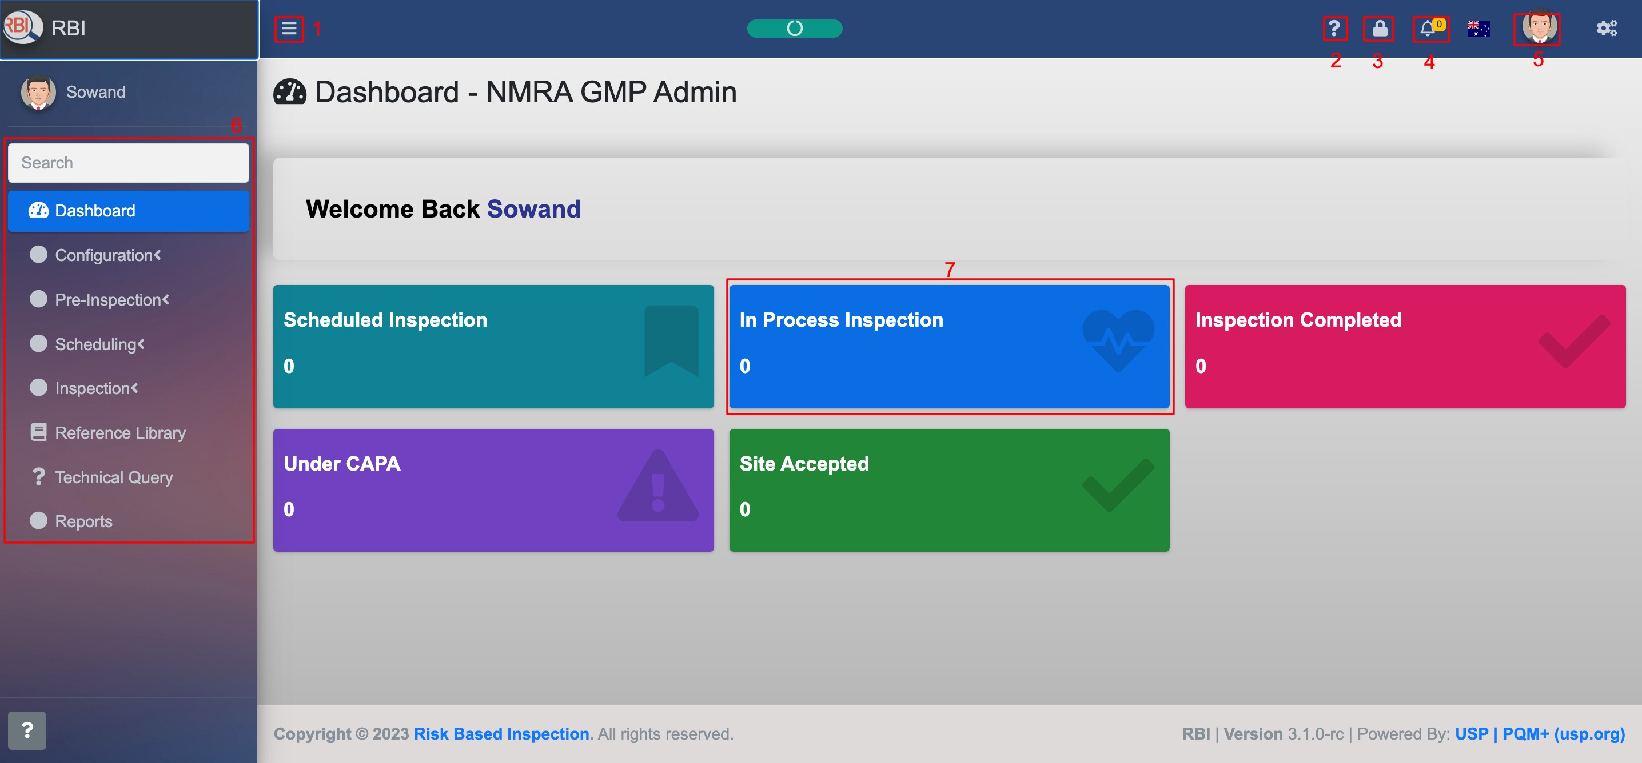
Figure 2: NMRA GMP Admin Dashboard
From the NMRA GMP Admin dashboard, the user can perform the following:
- Expand /Collapse Left-Navigation menu
- Help and User Guide of the Tool
- Lock the RBI Application
- View Notification Area
- Click on to expand the user profile and sign out links
- Left Menu Content
- View Dashboard area for the count and status of inspection performance

Lookup Interface
Lookup tables are set of summary-level inspections’ data for quick-reference. To access Lookup table, click on any item from the Left-navigation menu (For example Elements is clicked) as showing below:

Description of each component on the Lookup table
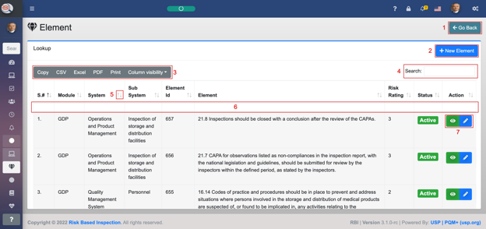
Figure: 3 Lookup Interface
Following is the explanation of each highlighted component with number:
- Go Back – When user will click on this button, user will be redirected to the parent-view.
- + New Element – This will open an empty form where user can create new record /item as the case may be in different modules and interfaces. This option is only available to the Admin user. In this case, this option is for Super Admin only.
- Lookup Table features – User can do the following from these features:

  - Copy the data table in clipboard
  - Export data in CSV format
  - Export data in Excel format
  - Export data in PDF format
  - Print current table date
  - Column-Visibility is used to show /hide columns in a lookup table for the current view of data
- Search – This feature is used to search a specific keyword from all the table columns
- Column Sorting – This feature is used to sort column data in Ascending or Descending order. Up and Down arrows sign is a toggle-link for both sorting orders
- Filtration of Column Data – User can narrow-down the table data by providing the keywords under each column, as appropriate.
- Action – This column normally contains action to be taken on each record. This column contains Edit and View buttons. These links are shown as per user rights defined by the Super Admin. Edit means user can modify the records and View means user can only view the record in Read-only mode.

New /Edit Form Interface
User can see following components in a new /edit form interface:
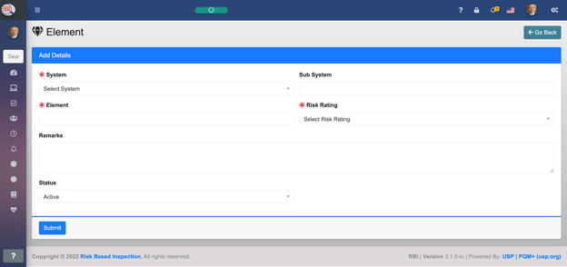
Figure – 4 – New /Edit Form Interface
Please note that all fields indicated with RED asterisk (*) are mandatory and user must select /input required data in these compulsory fields. After furnishing the required data in the respective columns /fields, user will select appropriate Status and will then click on Submit button that will save record in the database.

GMP Inspection Module – Web

The GMP Dashboard is the default view after successful login to the RBI Tool. This dashboard shows the total count of various Inspections that are in different stages of the inspection: Scheduled inspections, In Process. Under CAPA, and site accepted.

GMP Systems
NMRA GMP Admin has rights to view all pre-defined GMP Systems in the RBI Tool. To access these systems, From the left-navigation menu, click on Configuration menu and then click on System sub-menu and following interface will be displayed:
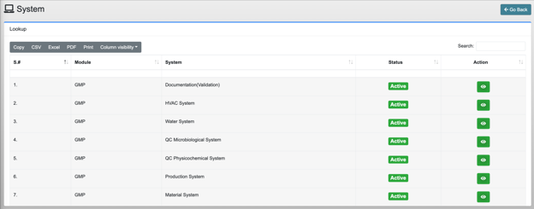
Figure 5: The GMP Systems Interface

To view the details of an Element, click on the green-eye icon under Action column of the lookup list. Following interface will be displayed to user:

There are two ways to add new manufacturer as described below:

To add a new manufacturer, user will click on pre-inspection menu on the left side where figure 5 will be displayed; then click on + New Manufacturer link where the following forms will be displayed:
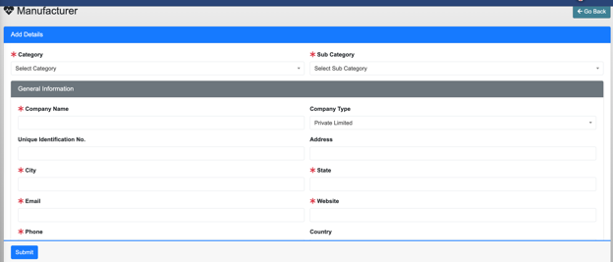
Figure 6: Adding New Manufacturer

Alternatively, to add a group of manufacturers at once, user can click on Download Template (see figure 5). Once template is downloaded on the local computer, NMRA Admin can complete the manufacturers’ data and then upload the CSV format file by using the Upload Data button (see figure 5). If file was created as per the instruction provided in the template, all manufacturers’ data entered into the template will be imported /uploaded into the manufacturers database at once.
To edit an existing manufacturer, from the Manufacturer lookup interface (under Action column), click on the respective blue-pencil icon button. Respective manufacturer’s record will be opened for the admin to modify.
Admin can also delete the Manufacturers’ bulk data from the system by clicking on the Delete Manufacturer button and this data can be deleted by providing the data when data was uploaded and this date can be seen under Uploaded Date Column of the Manufacturer’s lookup table. Please follow the instructions after clicking on Delete Manufacturer button.

Inspection Panel Pool
To access this interface, from the left-navigation menu, user will click on Pre-Inspection menu and will then click on Panel Pool sub-menu and following interface will be displayed to the NMRA Admin:

To Add new Panel member, click on + New Panel Member button and following interface will be displayed to the user where user will fill-in the required information and will submit the form to save in the database:
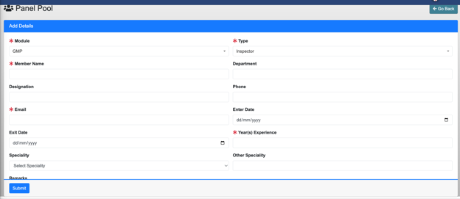
Figure 7: Adding New Panel Member

To View / Edit the existing panel member, user will click on the green-eye / blue-pencil button respectably from the Panel Member Lookup interface (under Action) button. This action will open an interface similar to the Image – 7 as discussed above.
Inspection Scheduling
To access the Scheduling, from the left-navigation menu, click on Scheduling menu and then click on GMP sub-menu. Following lookup interface will be displayed to NMRA admin:

To Schedule a new GMP Inspection, click on + New Inspection button. An interface will be opened to create new GMP inspection where inspector will provide all mandatory information and click submit button to save the record. Please note that be default inspection schedule will be saved as Draft. Once from all aspects inspection scheduling is completed, NMRA Admin will save the record by selecting status to Scheduled. This action will make this inspection available to the respective LEAD inspector who will carry-on the entire inspection accordingly. Following interface of GMP Inspection will be displayed to the user:

The very first default row will be there under Inspection Members section of the Inspection Scheduling interface. This default row is specific to the LEAD inspector. User can however click on the blue-plus (+) button to add another row for the inspection panel members against various roles like, Observer, Assistant and Support.
If Admin wants to delete a panel member, he /she can click on red-trash button against respective panel member.
NMRA Admin can also see the availability and engagement of Inspector’s Inspection Calendar before assigning the respective inspection to the inspector. To do so, NMRA Admin will click on the orange-calendar button and following Inspector calendar will be displayed on a new tab:

Now once inspection is ready to finalize and show it to the LEAD Inspector, NMRA Admin will select the Status as Scheduled and will submit the inspection and same inspection will be reflected on the LEAD Inspector of the respective inspection.
Please note that at any point, if inspector, by mistake has changed the inspection stage to the next stage, Inspector can’t change the stage to previous stage. For this, NMRA Admin has rights to change the inspection status as appropriate.
Once inspection is completed from LEAD Inspector, NMRA Admin will finally select Inspection Approved or Inspection Deferred and Closed status and will submit the inspection to complete the life-cycle of the inspection.

Reference Library
GMP Administrator can also create and view Reference Library which will also be available to all GMP inspector. To access this feature, NRMA Admin will click on the Reference Library link from the Left-Navigation menu. Following interface will be displayed to user:

Technical Query
Technical query is a medium of communication between various users of the tool to seek GMP /GSDP related technical assistance. This interface works like an email system where user can draft the required clarification on specific topic and can also attach the supporting document to clarify the seeking assistance. To get this feature, user will click on Technical Query link from the Left-Navigation menu and following interface will be displayed to the user:

To create a new Technical Query, user will click on + New Query button on top-right of the lookup. Following interface will be displayed to user:

On this interface, user will describe the technical assistance in the Message text area and for supporting the query, user may also attach up to 5 files as described on the interface. Once query is finalized, user will click on Submit button and this query will land on the Technical

GMP Assessment
Once an Inspection is scheduled and Lead Inspector is assigned to the respective inspection by the GMP Admin, Lead inspector, after, login will see the same inspection on his / her dashboard. To access the assigned GMP inspections, user will click on the Inspection menu from the Left-Navigation and will then click on GMP. Following user interface will be displayed:
User can see various inspections that may be on different stages. User will click on the blue edit button to open the desired inspection for the execution purposes. After confirmation from the user to Edit the inspection, following interface will be shown to the user:
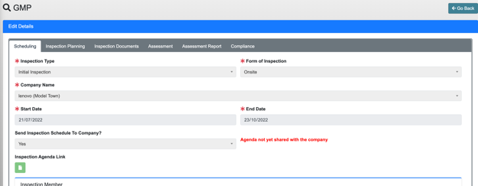
Figure:8 GMP Inspection Scheduling Interface
On this interface, Initially, there are total 6 tabs where all relevant sections’ information is available for the inspector to start with the inspection execution related activities and later on, based on the inspection status, other tabs like CAPA and System Dashboard tabs will be visible that are described below:
Scheduling Tab
Scheduling tab contains all information pertaining to the manufacturer information like, Manufacturer Name, Inspection Type, Form of Inspection, Inspection Dates, Panel Members, etc.
Inspection Planning Tab
Inspection Planning tab is a place where Inspector will select system-wise elements that are applicable for this inspection. By default, all elements will be selected, Inspector will un-check the element which is not required for the specific company and type of inspection. Once done, Inspector will submit the inspection so that it could be saved in the system to perform the remaining steps of the inspection.
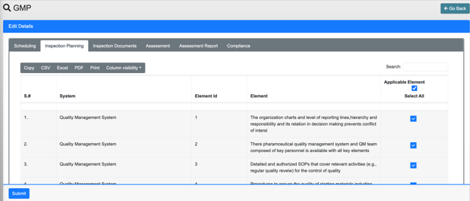
Figure : 9 – GMP Inspections – Inspection Planning
Inspection Documents Tab
Inspection Document tab contains Agenda |Attachment, Site Master File, QIS File, Opening Meeting Remarks, Closing Meeting and Remarks and the like. The user interface is shown as below:
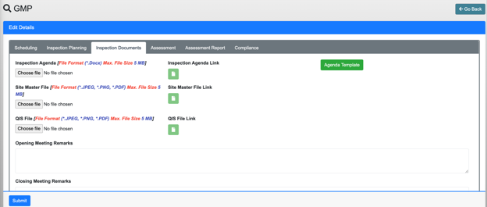
Figure – 10 – GMP Inspections – Inspection Interface
Assessment Tab
Assessment tab contains the core functionality of the GMP inspection module to assess various system level elements to see the compliance level of each related function. Following interface will depict the functionality of the GMP Assessment interface:
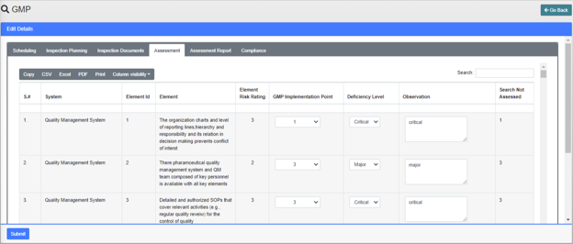
Figure:11 GMP Assessment Interface
If Inspector wants to see if there’s some element which was not assessed, this can be viewed as “Not Assessed” in the filter area of the last column of the assessment tab.

will show the compliance level of various systems and their respective elements:

The moment inspection is set as Completed by the inspector, there will be other tabs known as CAPA and System Dashboard will be displayed to the inspector to generate CAPA from the system and start follow-ups with the company to address the CAPA. Following CAPA tab / interface will be made visible by the system upon completion of the inspection:
Assessment Dashboard Tab
System Dashboard shows Pie-charts that depict total Systems-wise elements counts against each system as shown below:
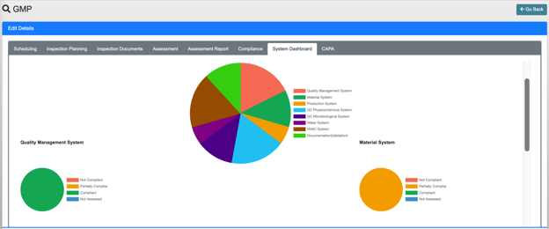
Figure : 12 – GMP Inspections – Compliance Interface
CAPA Tab
In this tab, Inspector can download the CAPA template that will be generated by the system using all data inputs and system generated data for the particular inspection. Inspector can also record all CAPA follow-ups with the manufacturer on this interface as shown below:
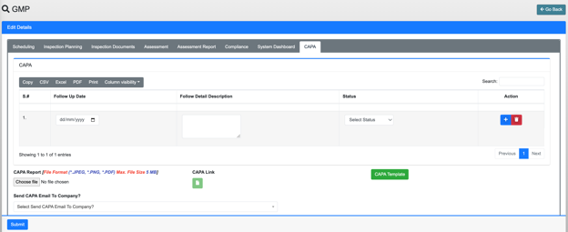
Figure : 13 – GMP Inspections – CAPA /Follow-up Interface

GMP Inspection Module – Mobile Interface

NMRA GMP Inspector
Country level GMP Inspector of the RBI Tool will login into the mobile app by using the login credentials received from the RBI Tool. The credentials are the same for both web and mobile app. This mobile app is meant for the offline GMP inspection and thus it’s to be used by the Inspector during the execution of the scheduled inspection and when there is no internet available on the inspection site.
After successful installation of the Risk-Based Inspection App, Inspector will tap on the Risk-Based Inspection icon and following splash interface will be displayed to the user:
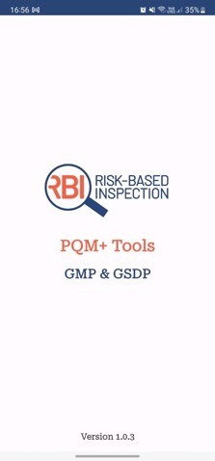
Figure :14 – Mobile App – Splash Screen
After the splash screen (couple of seconds), the landing page will be displayed to user where GMP and GSDP short description will be available. The interface will be shown as below:

Figure :15 - Mobile App - Landing Page
After swapping the screen to right-side as indicated on the main landing page, user will see the login screen as shown below:
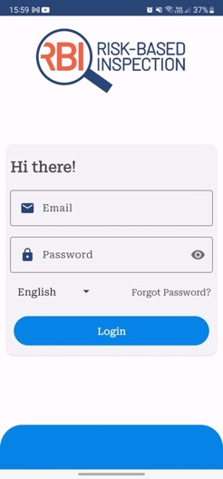
Figure :16 - Mobile App – Login Page
After successful login, App will try to fetch the latest inspection data from the server. Following interface will be displayed to user:
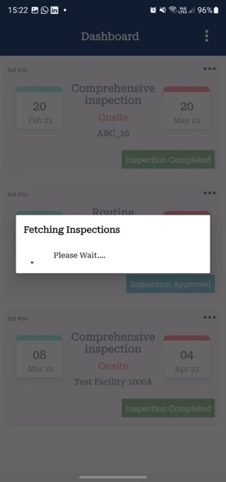
Figure :17 - Mobile App – Fetching Data from the server
Once data is fetched from the server, user could see following interface where user can see the inspection category, like GMP inspection or GSDP inspection, Inspection Start Date, Inspection End Date, Company Name, Inspection Type, Form of Inspection and Inspection Status.
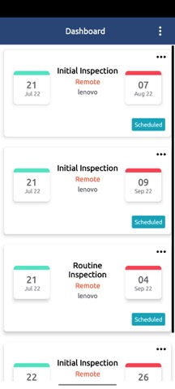
Figure :18 - Mobile App – Assigned Inspections
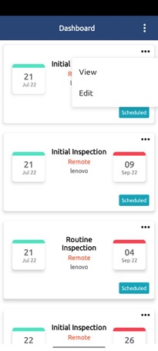
Figure :19 - Mobile App – Assigned Inspections

To go inside the inspection functions, user will tap on three dots (…) menu which is available on the top-right corner respective inspection. Here is something important to note as below:
If Inspection is under Scheduled or In Process stage, user will see the menu Items as below:
- View (Where user can view the details of the inspection in Read-Only mode.)
- Edit (Where user can edit the inspection information as needed.)
If Inspection is under Inspection Completed stage following menu items will be available to user:
- View (Where user can view the details of the inspection in Read-Only mode.)
- Sync (To sync the offline inspection data with online server)
Once Inspection is successfully synchronized with the server, the Delete option will override the Sync option to delete the local inspection record, if needed by the inspector to save the storage.
For the inspection execution, Inspector will click on the Edit option from the three dots (…) menu of the respective inspection and following interface will be available to the user:
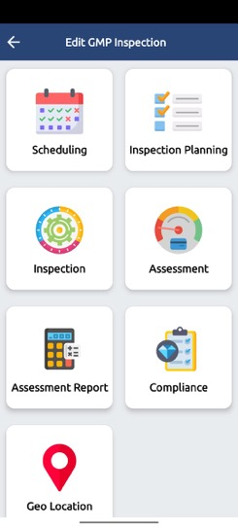
Figure :20 - Mobile App – Inspection Execution Functions
Scheduling
Under scheduling, inspector can see the same scheduling information as we discussed in the web interfaces of the inspection. When user will tap on the Scheduling icon, following interface will be displayed:
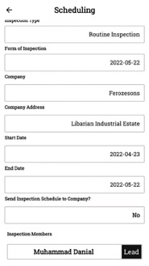
Figure :21 - Mobile App – Inspection Scheduling
Inspection Planning
Under Inspection Planning, Inspector will select the applicable System-Wise Elements from the following interface where user can user Select All /Deselect All elements by checking the Applicable Elements checkbox which has toggle functionality:
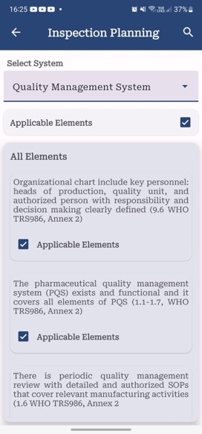
Figure :22 - Mobile App – Inspection Planning

Inspection
On this function, inspector can upload Inspection Agenda and other related documents along-with opening and closing meeting remarks by using following interface:
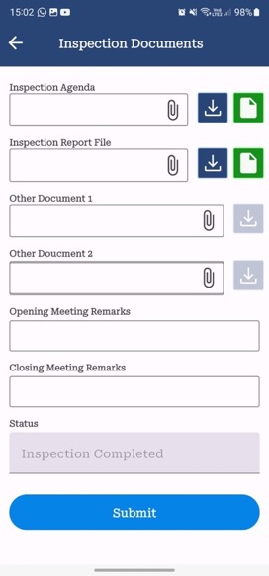
Figure :23 - Mobile App – Inspection Document
Assessment
The core function of the inspector is to assess various systems and their respective elements by providing the appropriate GMP scoring. Inspector will tap on the Assessment icon and following interface will be displayed to the user where user can tap on any of the element and edit interface will be displayed as shown in the below images:
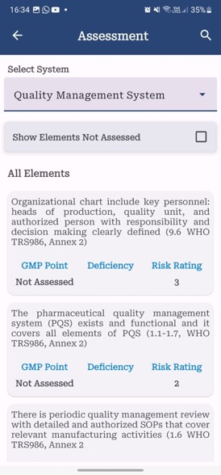
Figure :24 - Mobile App – Assessment interface
Note: To figure out which elements were not assessed, inspector can Show Elements Not Assessed check box and app will display all those elements that were missed out among all applicable elements.
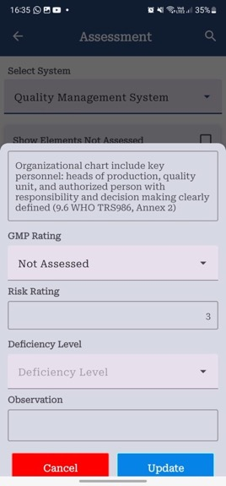
Figure :25 - Mobile App – Assessment interface – Edit interface

Assessment Report
Once assessment is completed, user will set the status as In Process and will save this assessment. All changes made in this inspection will be saved and Inspection status will be set as In Process. Now, it’s time to see various calculations of the inspection as we discussed in the web Interface of the RBI Tool user guide. From the main functions of the Inspection (Image 10.5), user will tap on Assessment Report and following interface will be displayed to user where user can swipe the interface from left-to-right and from right-to-left navigation across all systems of the GMP Systems:
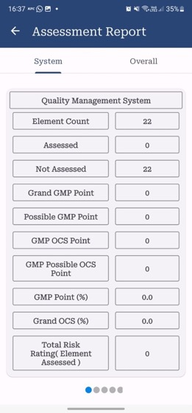
Figure :26 - Mobile App – Assessment Report interface
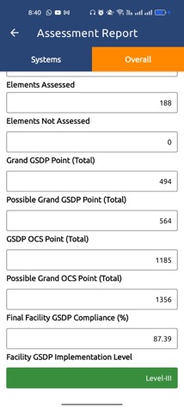
Figure :27 - Mobile App – Assessment Report interface - Overall
Compliance
After validating the assessment report from the above-mentioned interface, Inspector will now tap on Compliance icon to see system-wise and company level compliance of the GMP inspection. Following interface will be displayed where user can swipe the interface from left-to-right and from right-to-left navigation across all systems of the GMP Systems:
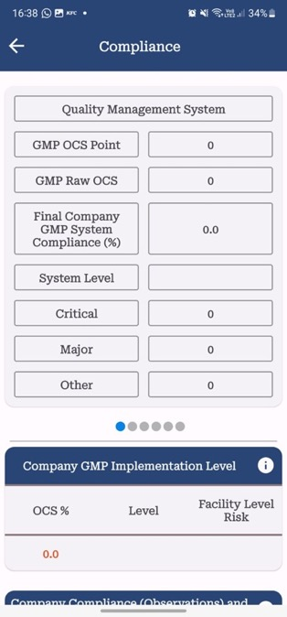
Figure :28 - Mobile App – Compliance interface
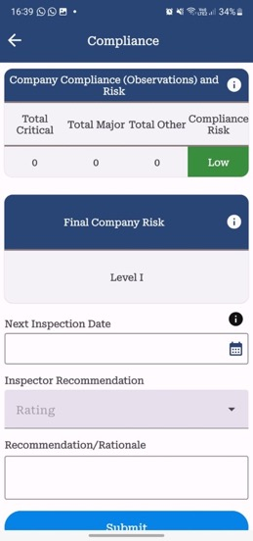
Figure :29 - Mobile App – Compliance interface – Final Scoring

GEO Location
To find and save the current GEO Location of the company, user will tap on the Geo Location icon and system will automatically find the current geo-location of the company where inspector came for the inspection. User can save the location of the company in the RBI Tool for future references. Following interface will be displayed to user:

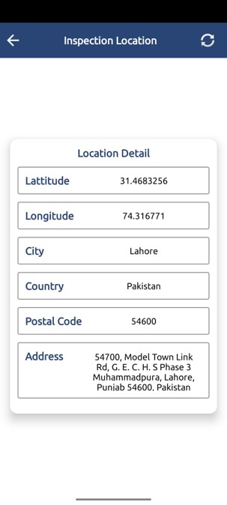
Figure :30 - Mobile App – Inspection Geo-Location interface
Contact Us Form
In case, if Inspector wants to ask any question from the PQM+ Admin, user can fill a form as we discussed in the web interface of the GMP Module. User will tap on the Contact Us form from the menu and following interface will be displayed to user:
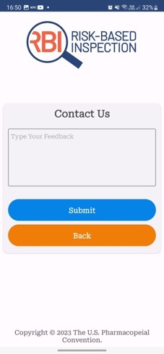
Figure :31 - Mobile App – Contact Us interface

GSDP Inspection Module – Web

NMRA GSDP Admin
Country level Admin of the RBI Tool (GSDP) will login into the tool by using the login credentials received from the RBI Tool. After successful login, Admin will have the following functions that are available on the left-navigation menu:

GSDP Dashboard
GSDP Dashboard is the default view after successful login to the RBI Tool. This dashboard shows the total count of various Inspections that are in different stages of the inspection. Like already Scheduled inspections and few of them are In Process and some may have Under CAPA stage and so on. User can see the following interface soon after his /her login. Following interface will be displayed as default interface after login:
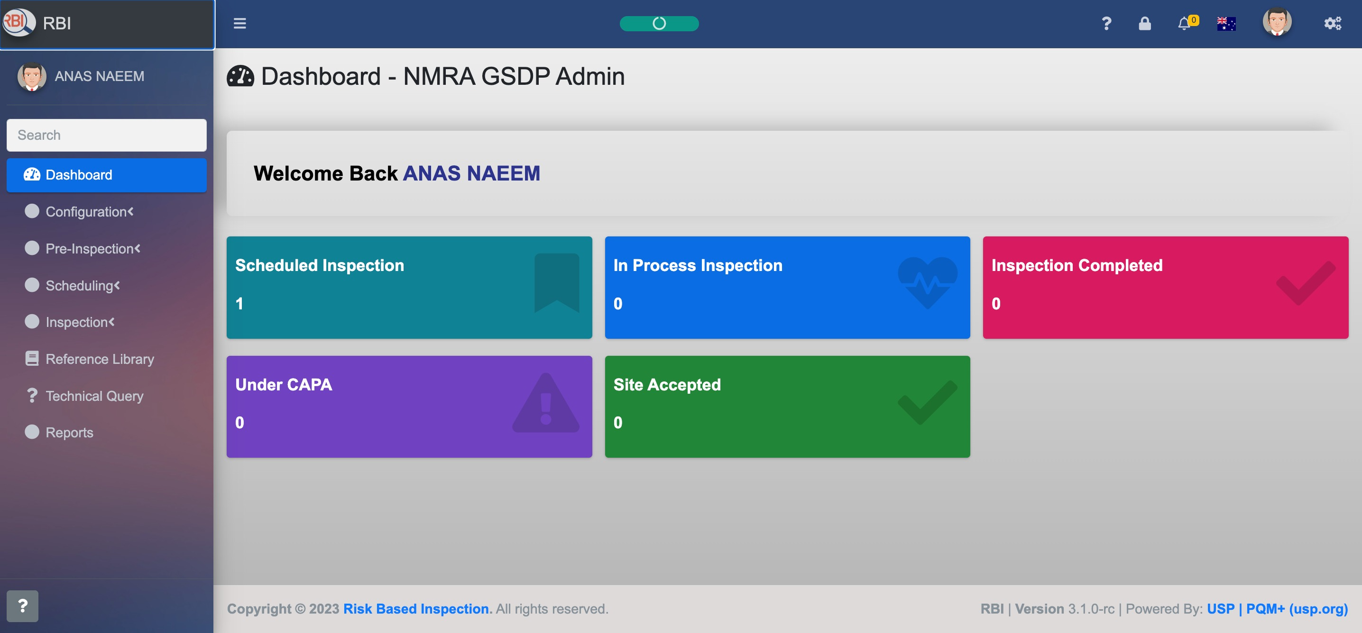
Figure :32 – Dashboard View

GSDP Systems
NMRA GSDP Admin has rights to view all pre-defined GSDP Systems in the RBI Tool. Super Admin is the person who actually defines and updates the system in the tool. To access these systems, From the left-navigation menu, user will click on Configuration menu and will then click on System sub-menu and following interface will be displayed:
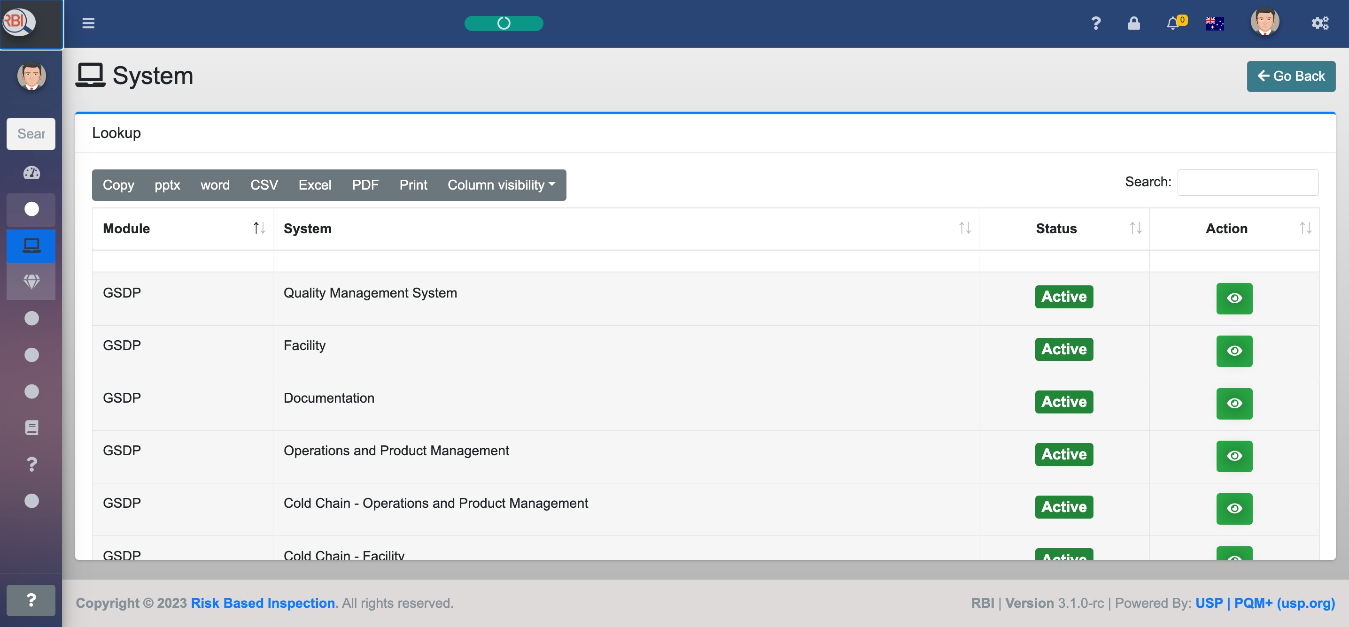
Figure :33 – List of Pre-defined GSDP Systems
GSDP System Elements
NMRA Admin can also view the System Elements that will also show the Element wise Risk Rating in the view. These elements are further classified in 3 facility groups and GSDP can set this classification either by editing single record one-by-one or by downloading template and after update uploading it back in the tool. To access this interface, from the left-navigation menu, user will click on Configuration and then will click on Element sub menu and following interface will be displayed to the user:
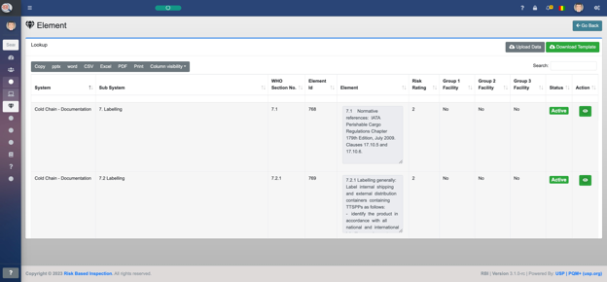
Figure :34 – List of Pre-defined GSDP System, Sub-System, Elements & Risk Rating

To view the details of an Element, click on the green-eye icon under Action column of the lookup list. Following interface will be displayed to user:
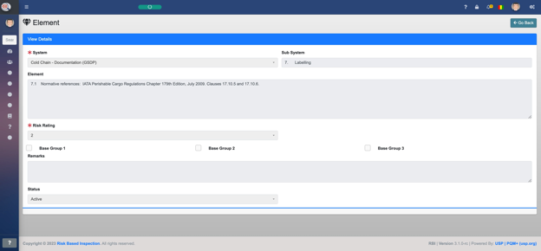
Figure :35 – GSDP System Elements & Risk Rating – Form View

Facilities
To access Facilities, from the left-navigation menu, click on Pre-Inspection menu and then click on Facilities sub-menu and following interface will be displayed:
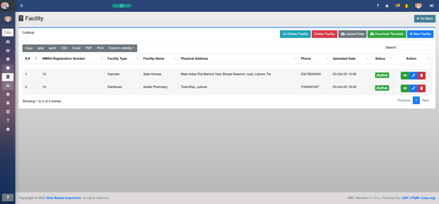
Figure :36 – List of Facilities – Short View Image

There are couple of ways to add new facility as described below:
Figure :37 – Adding Facilities – Possible Options
To add a new facility manually, user will click on + New Facility link and following forms will be opened for the NMRA Admin to furnish all required information in the form and Submit the same form to save the new facility in the RBI Tool Database of respective NMRA:
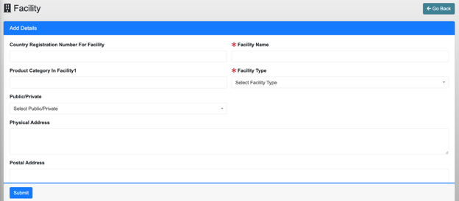
Figure :38 – Adding Facility – Facility Adding Form

To add facilities in bulk quantity, user will click on Download Template. Once template is downloaded on the local computer, NMRA Admin will read the Instructions sheet of the template carefully and will accordingly process the facilities’ data in the sheet. After following all instructions, NMRA Admin will upload the CSV format file by using the Upload Data button. If file was created as per the instructions and was successfully uploaded, all facilities’ data will be imported /uploaded in the facilities database and same can be verified on the lookup view of facilities.
To edit an existing facility, from the Facility lookup interface (under Action column), click on the respective blue-pencil icon button. Respective facility’s record will be opened for the admin to modify. Similar interface will be displayed as we saw in Image – 11.4.3.
To delete already entered facilities in the system, user will click on Delete Facility button and an interface will be opened where user will select the appropriate data of the facility data that was imported on and from the list, select Facility. When user will press the Submit button, all data matching with given parameters will be deleted from the system after confirmation from the user.
To Un-Delete the already deleted facilities, user will click on Un-Delete Facility button on the top of Facility lookup table. Un-Delete facility interface will be displayed and user will select the date when the facilities were created. After Submission, all facilities will be undeleted that were deleted earlier and were created on the selected date.
Panel Pool
Panel pool is an essential and integral part of inspection process where GSDP inspectorate personnel are defined along-with their area of expertise, years of experience and other relevant details. To access this interface, from the left-navigation menu, user will click on Pre-Inspection menu and will then click on Panel Pool sub-menu and following interface will be displayed to the NMRA Admin:
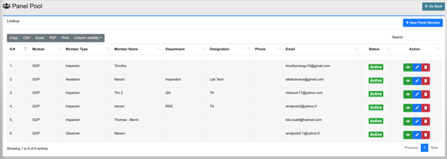
Figure :39 – Panel Pool – Lookup Interface

To Add new Panel member, user will click on + New Panel Member button and following interface will be displayed to the user where user will fill-in the required information and will submit the form to save in the database:
Figure :40 – Panel Pool – Add New Panel Member – Add Form
To View / Edit the existing panel member, user will click on the green-eye / blue-pencil button respectably from the Panel Member Lookup interface (under Action) button. This action will open an interface similar to the Image – 11.5.1 as discussed above.
To Delete the panel pool member, user will click on Delete button and member will be deleted after getting confirmation from the user.
Scheduling
This is the core function of the GSDP Admin to schedule various types of inspections. To access the Scheduling, from the left-navigation menu, user will click on Scheduling menu and then click on GSDP sub-menu. Following lookup interface will be displayed to NMRA admin: 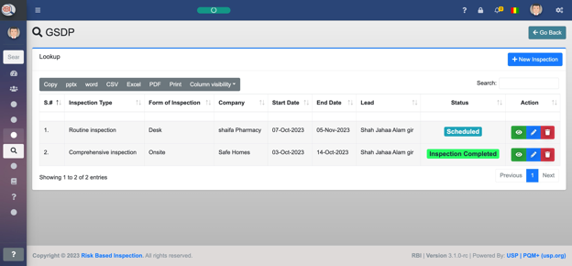
Figure :41 – Inspection Scheduling – Lookup Interface
To Schedule a new GSDP Inspection, NMRA Admin will click on + New Inspection button. An interface will be opened to create new GSDP inspection where inspector will enter all mandatory information in the form and will submit the form to save the record. Please note that by default inspection schedule will be saved as Draft. Once from all aspects inspection scheduling is completed, NMRA Admin will save the record by selecting status to Scheduled. This action will make this inspection available to the respective LEAD inspector who will carry-on the entire inspection accordingly. Following interface of GSDP Inspection will be displayed to the user:
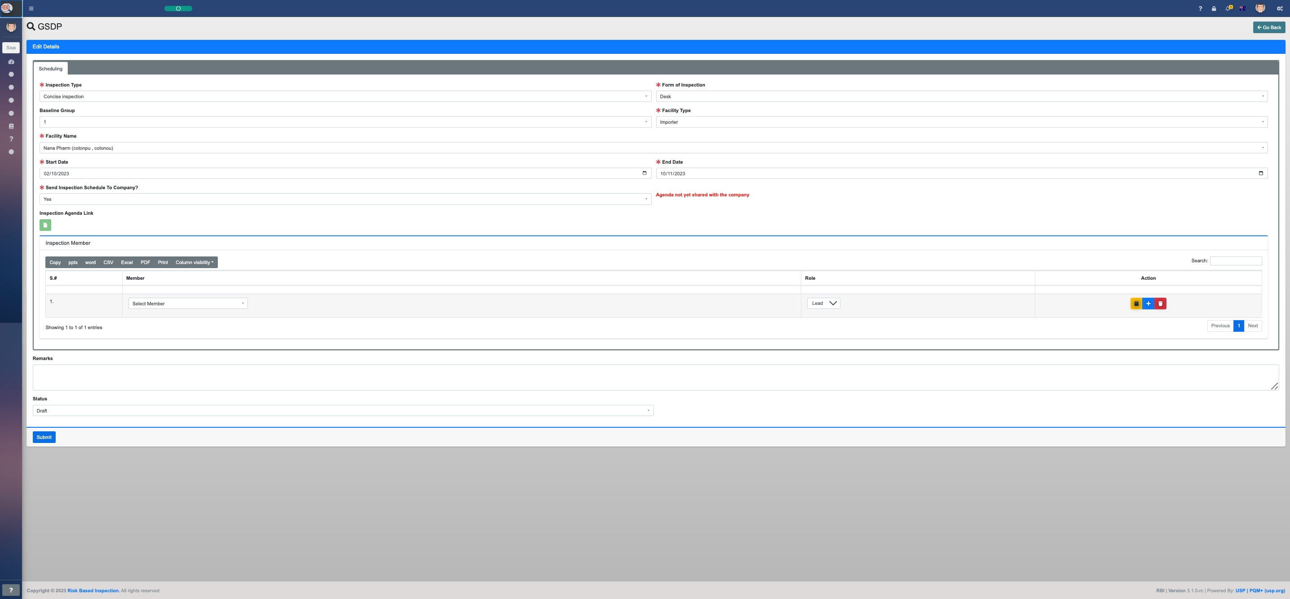
Figure :42 – Inspection Scheduling – New GSDP Inspection Schedule
While assigning panel members to the inspection, NMRA Admin has following options as displayed in the image where in the first row, the Lead inspector will always be selected and Admin can add other panel members by clicking the plus sign under Action column to add observer or assistant as the case may be:
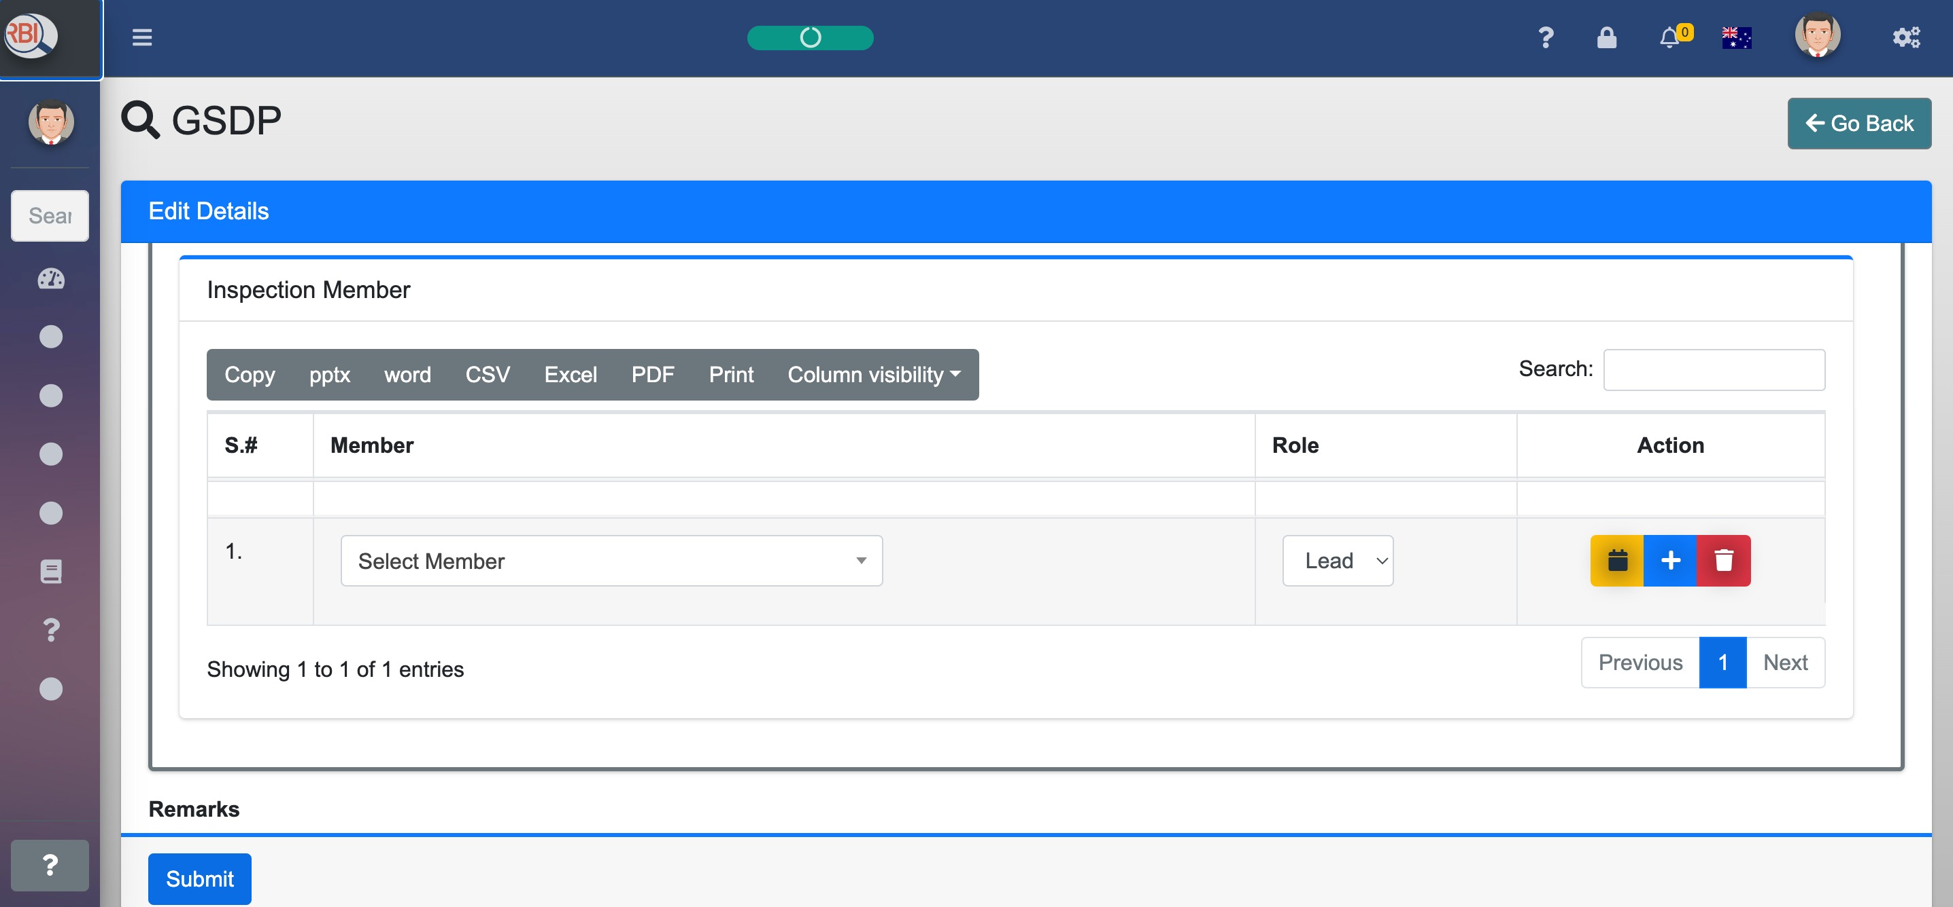
Figure :43 – Inspection Scheduling – Adding Panel Members
The very first default row will be there under Inspection Members section of the Inspection Scheduling interface. This default row is specific to the LEAD inspector. Along-with the selected member, NMRA Admin can also see the specialty and number of years of experience of the member as well. User can however click on the blue-plus (+) button to add another row for the inspection panel members against various roles like, Observer, Assistant and Support.
If NMRA Admin wants to delete a panel member, he /she can click on red-trash button against respective panel member.
NMRA Admin can also see the availability and engagement of Inspector’s Inspection Calendar before assigning the respective inspection to the inspector. To do so, NMRA Admin will click on the orange-calendar button and following Inspector calendar will be displayed on a new tab:

Now once inspection is ready to finalize and show it to the LEAD Inspector, NMRA Admin will select the Status as Scheduled and will submit the inspection and same inspection will be reflected on the LEAD Inspector of the respective inspection and Inspector will also get an email notification for the inspection.
Please note that at any point, if inspector, by mistake has changed the inspection stage to the next stage, Inspector can’t change the stage to previous stage. For this, NMRA Admin has rights to change the inspection status as appropriate.
Once inspection is reviewed and validated by the LEAD Inspector, NMRA Admin will finally select Inspection Approved or Inspection Deferred and Closed status and will submit the inspection to complete the life-cycle of the inspection.
View Inspection Execution
NMRA Admin can see the inspections that are in various stages, like;
Scheduled (Means inspection is now scheduled and it’s now available to inspector to start working on it)
In Process (By this status it means that inspector has started working on it)
Inspection Completed (This means that inspector has completed all activities to conduct an inspection)
Under CAPA (Under CAPA means that CAPA process has been started and inspector is now coordinating with the facility concerned staff to close the CAPA)
Inspection Approved (It means that inspection was successful and facility meets all required standards)
Inspection Deferred and Closed (This means that inspection was not successful and based on the inspection report, facility doesn’t meet the required standards).
To see the on-going inspections, from the left-navigation menu, NMRA Admin will click on Inspection menu and will then click on GSDP sub-menu that will open the following lookup page:
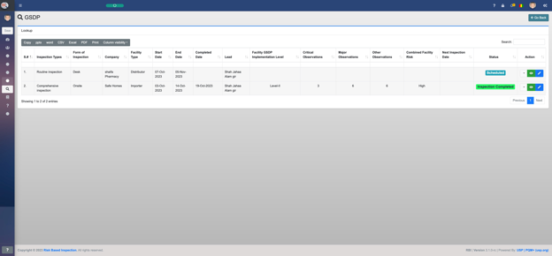
Figure :44 – Inspections – View on-going inspections
To see the details of the on-going inspection, NMRA Admin will click on the View /Edit button under Action column of the lookup and following interface will be displayed:
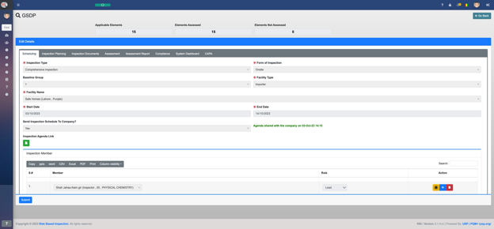
Figure :45 – Inspections – View on-going inspections – Details
On this interface, NMRA Admin can see the details of the on-going inspections. Following tabs are available to the NMRA admin as well:
- Scheduling
This will show the Inspection scheduling details (Company Name, Inspection Start Date, End Date, Lead Inspector, etc.)
- Inspection Planning
Inspection planning area where Inspector will select all applicable system-wise
elements for the specific inspection.
- Inspection Documents
This tab will have the Auto-generated Inspection Agenda, Site Master File, Opening
/Closing Meeting remarks, Auto-generated Inspection Report, etc.
- Assessment
Assessment tab will have the system-wise elements scoring, Overall score and observations on each element.
- Assessment Report
System-wise Assessment report including, Element Count, Element Assessed, Grand GSDP Point, Possible GSDP Point, Grand OSC Point, Total Risk Rating, Possible OSC Point, GSDP Score & Grand OSC Point. This will also have the total of these calculations as well.
- Compliance
Compliance Tab will show System-Wise as well as Company Compliance Level based on the Grand OSC Point calculated in the Assessment Report tab.
- System Dashboard
This tab will show the System-wise Element Count and Possible Score with their totals as well.
- CAPA (This tab will only be visible when inspection status is Under CAPA)
This shows the auto-generated CAPA template, uploaded final CAPA document and CAPA Follow-up history with the company.
Please note that details of these interfaces /tabs can be seen in NMRA Inspector’s module in the following sections of this operation manual.
Reference Library
The reference library is a repository of regulatory guidance documents adopted and/or issued by NMRAs to enforce regulatory inspection process
GSDP Administrator can also create and view Reference Library which will also be available to all concerned stakeholders. To access this feature, NRMA Admin will click on the Reference Library link from the Left-Navigation menu. Following interface will be displayed to user:
Note: Reference library can be created by Super Admin, NMRA Admin and by NMRA Inspector.
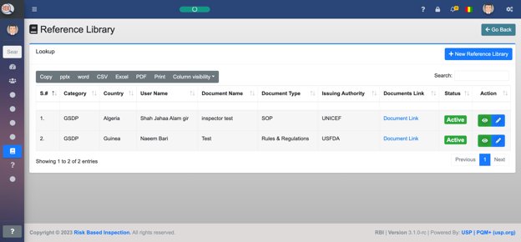
Figure :46 – Reference Library – Lookup interface
To create a new Reference Library, NMRA admin will click on + New Reference Library from to-right of the interface. User will see the following Reference Library creation form:
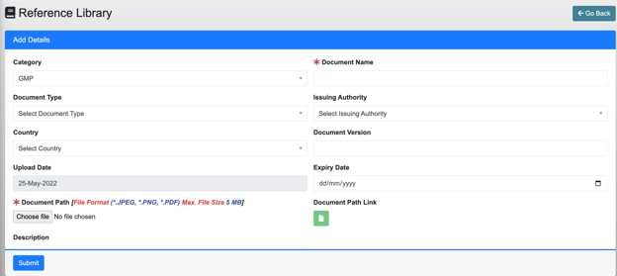
Figure :47 – Reference Library – New Reference Library – Add /Edit Interface
NMRA Admin will enter all required inputs in the form and will click on the Submit button to save this reference library that will be visible in the Reference Library Lookup interface.
Technical Query
Technical query is a medium of communication among NMRA stakeholders (NMRA Admin & NMRA Inspector & Super Admin) to seek GSDP /GMP related technical assistance. This interface works like an email system where user can draft the required clarification on specific topic and can also attach the supporting document to clarify the seeking assistance. To get to this feature, user will click on Technical Query link from the Left-Navigation menu and following interface will be displayed to the user:
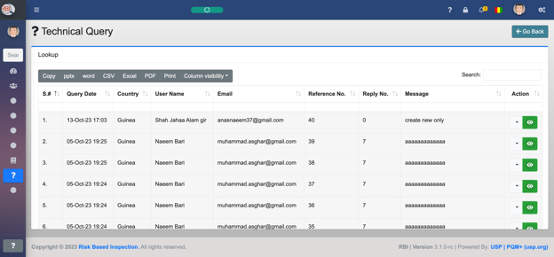
Figure :48 – Technical Query – Lookup Interface
To create a new Technical Query, user will click on + New Query button on top-right of the lookup. Following interface will be displayed to user:
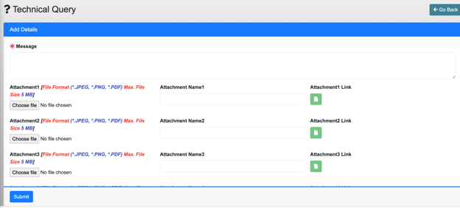
Figure :49 – Technical Query – Create new query
On this interface, user will describe the technical assistance in the Message text area and for supporting the query, user may also attach up to 5 files as described on the interface. Once query is finalized, user will click on Submit button and this query will land on the Technical Query interface of the Super Admin interface who will reply back to the sender and same reply will be visible to the sender.

NMRA GSDP Inspector – Web
Country level Inspector of the RBI Tool (GSDP) will login into the tool by using the login credentials received from the RBI Tool. After successful login, Inspector will have the following functions that are available on the left-navigation menu:
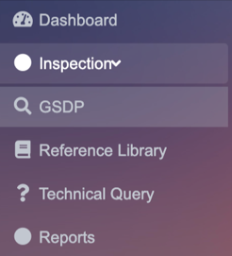
Figure :50 – Available functions for GSDP Inspector

GSDP Dashboard
GSDP Dashboard is the default view after successful login to the RBI Tool. This dashboard shows the total count of various Inspections that are in different stages of the inspection life-cycle. Like already Scheduled inspections and few of them are In Process and some may have Under CAPA stage and so on. Following interface will be displayed as default interface after login:
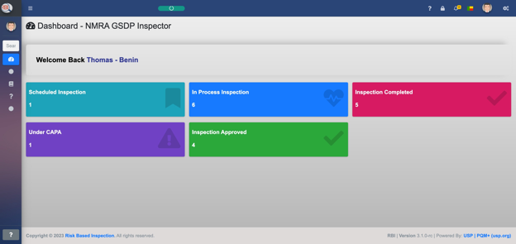
Figure :51 – Dashboard View
GSDP Inspection
Once an Inspection is scheduled and Lead Inspector is assigned to the respective inspection by the GSDP Admin, Lead inspector, after, login will see the same inspection on his / her dashboard. To access the assigned GSDP inspections, user will click on the Inspection menu from the Left-Navigation and will then click on GSDP. Following user interface will be displayed:
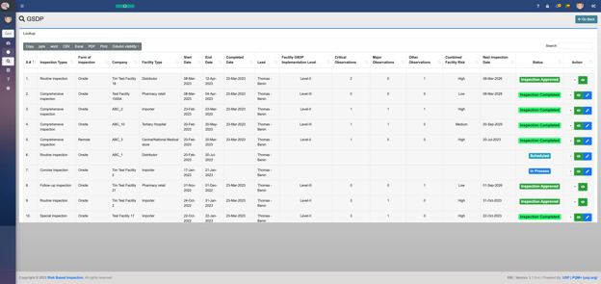
Figure :52– GSDP Inspections - Lookup
On the above interface, user can see various inspections that may be on different stages. User will click on the blue edit button to open the desired inspection for the execution purposes. After confirmation from the user to Edit the inspection, following interface will be shown to the user:
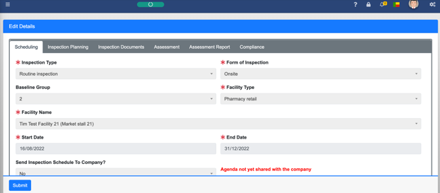
Figure :53 – GSDP Inspections – Scheduling Interface
On this interface, there total 6 tabs where all relevant sections’ information is available for the inspector start with the inspection execution related activities that are described below:

Scheduling Tab
Scheduling tab contains all information pertaining to the facility inspection like, Facility Name, Inspection Type, Inspection Form of Inspection, Inspection Dates, Panel Members, etc.
Inspection Planning Tab
This tab will contain the system-wise elements that will be selected by the GSDP Inspector which are applicable to the specific inspection. The selected elements will be used for the rest of the inspection process.
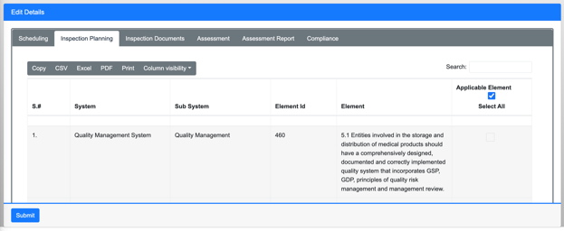
Figure :54 – GSDP Inspections – Inspection Planning
Inspection Tab
Inspection tab contains Agenda Attachment, Site Master File, QIS File, Opening Meeting Remarks, Closing Meeting Remarks and Inspection Report. User interface is shown as below:
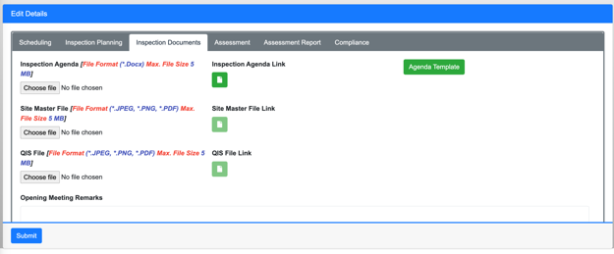
Figure :55 – GSDP Inspections – Inspection Interface

Assessment Tab
Assessment tab contains the core functionality of the GSDP inspection module to assess various system level elements to see the compliance level of each related function. Following interface will depict the functionality of the GSDP Assessment interface:
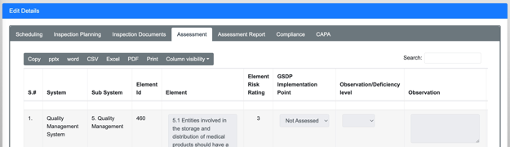
Figure :56 – GSDP Inspections – Assessment Interface
If Inspector wants to see if there’s some element which was not assessed, Inspector can see all un-assessed elements using filter options by writing “Not Assessed” in the filter area of the last column of the Assessment tab.
Assessment Report Tab
The Assessment Report data on this tab is dependent on the data of the Assessment tab itself. The data input on the Assessment tab by the Inspector will be automatically calculated by the system and will be displayed to user’s review. Inspector can also download the Inspection Report Template that will be generated by system itself and all relevant information will be pre-populated in the template. Following interface will be displayed to user:
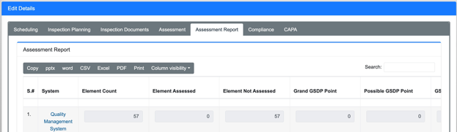
Figure :57 – GSDP Inspections – Assessment Report Interface
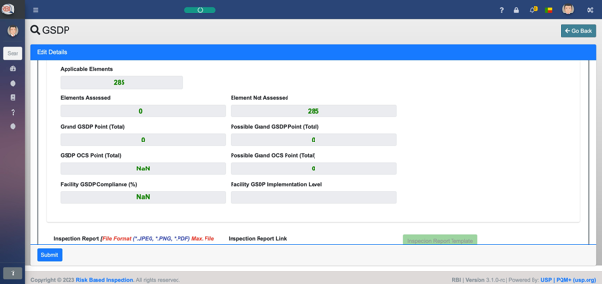 Figure :58 – GSDP Inspections – Assessment Report Interface - Calculations
Compliance Tab
In this tab, Inspector can see system-wise and company-wise compliance level which is calculated automatically by the system that is based on the assessment of the inspector against various system-wise elements. Following interface will show the compliance level of various systems and their respective elements:
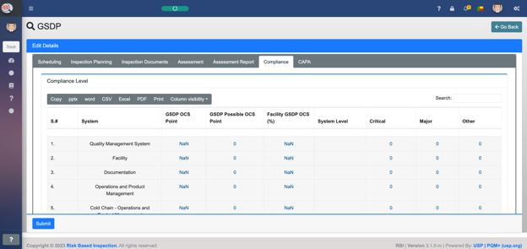
Figure :59 – GSDP Inspections – Compliance Interface
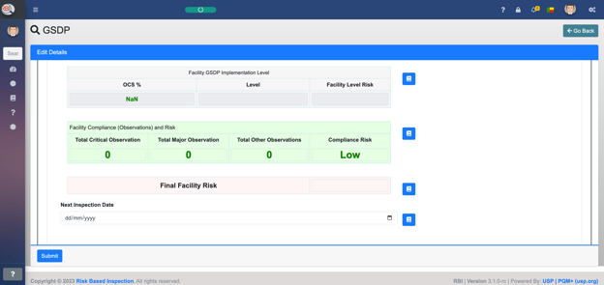
Figure :60 – GSDP Inspections – Compliance Interface – Facility and Risk Level
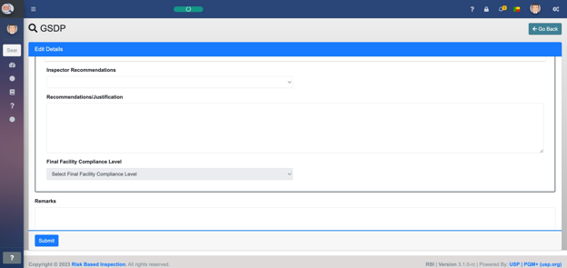
Figure :61.1 – GSDP Inspections – Compliance Interface – Facility and Risk Level

The moment inspection is set as Completed by the inspector, there will be another tab known as CAPA will be displayed to the inspector to generate CAPA from the system and start follow-ups with the company till its compliance. Following CAPA tab / interface will be made visible by the system upon completion of the inspection:
System Dashboard Tab
System Dashboard shows total Systems elements counts against each system and possible score of these elements as shown below:
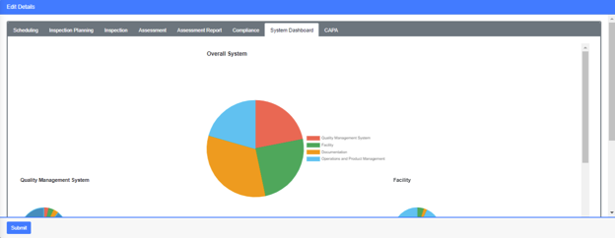
Figure :62 – GSDP Inspections – System Dashboard Interface
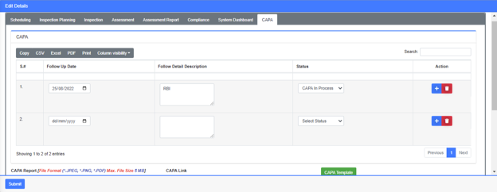
Figure :63 – GSDP Inspections – CAPA /Follow-up Interface

General Instructions

Internet browser recommendations for optimum output

Please consider the following general instructions for the optimum utilization of the RBI Tool:
- For best look and feel of the RBI Tool, please use the following latest web browsers:
  - Google Chrome
  - Microsoft Edge
  - Firefox Mozilla
  - Safari
  - Opera
- Reasonable internet speed to host this application for the NMRA routine operation and it’s to be determined by NMRA IT staff.

Support

Technical Support

For any technical support related to RBI Tool user can contact the under-signed:
PQM+
Call:1-800-227-8772, +1-301-881-0666, or 00-800-4875-5555
Email: pqm@usp.org

Annexure-A
RBI Tool Troubleshooting guide

Introduction
This troubleshooting guide will be used by the Super Administrator of the RBI Tool during a scenario where the user might encounter with issues for further processing of the inspection process. This guide will be considered as Knowledge-Base (KB) document as well for certain issues that may pop-up during the execution of the Super Admin functions. Super Admin can search by keywords for scenario of the relevant issue.
All possible scenarios are mentioned below to see the proper solution of the issue they are facing with:
- Email Failure: System is not sending emails against various triggering points, like:
- New user account credentials for NMRA admin an inspector
- Password reset emails (I forgot my password)
- Inspection Assignment
- Inspection Agenda to Company
- CAPA email to company, etc.
- Technical query and communication between internal user and the company
REASON: Email configurations are not set properly on the hosting server site as indicated in the below section.
Steps to follow: Super Admin will follow these steps:
- Step-1: Check the SMTP email settings in the following file:
  - application/helpers/cias_helper.php
- Step-2: Make sure this file has proper smtp settings as per your current environment and sample settings are shown below:
==========================================

if(!function_exists('setProtocol'))
{
function setProtocol()
{
$CI = &get_instance();

$CI->load->library('email');

$config['protocol'] = 'smtp'; // smtp
//$config['mailpath'] = '/usr/sbin/sendmail'; //

// final working
$config['smtp_host'] = theServer;
$config['smtp_port'] = '587';
$config['smtp_user'] = theEmail;
$config['smtp_pass'] = 'thePassword;
$config['smtp_auth'] = TRUE;
$config['smtp_crypto'] = 'no';
// final working

//$config['timeout'] = '7';
//$config['smtp_crypto'] = 'ssl';
$config['charset'] = 'UTF-8';
$config['mailtype'] = 'html';
$config['newline'] = "\r\n";

$CI->email->initialize($config);

return $CI;
}
}
==========================================

- RBI Landing Page Errors: After entering the RBI URL, the landing page is not shown properly and shows an error message like below figure:
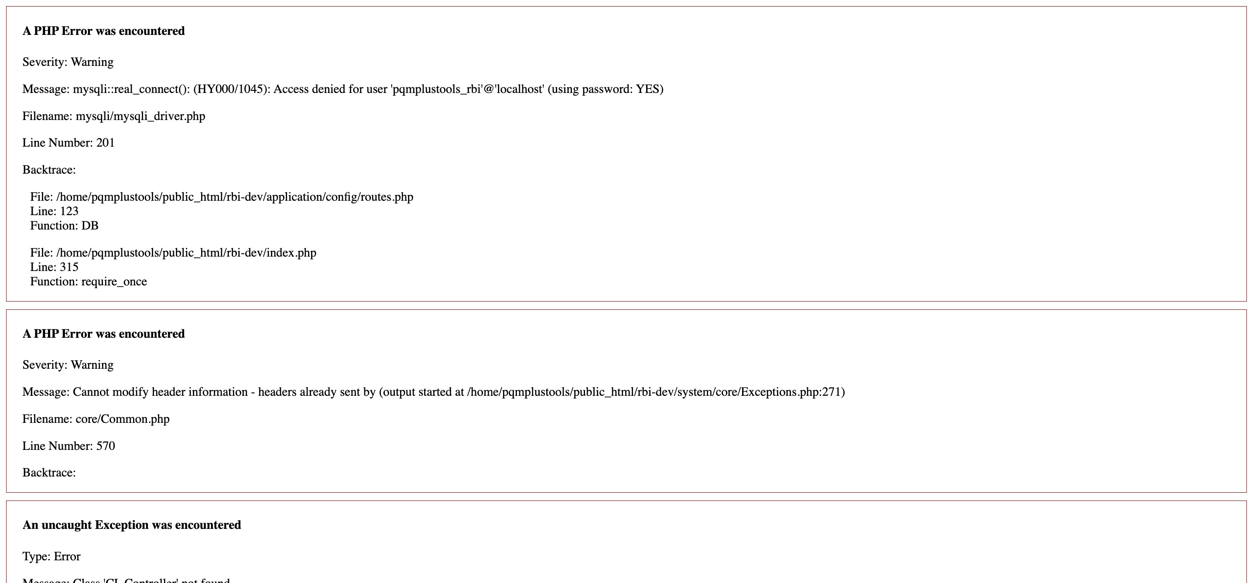
REASON: Database configurations are set properly on the server side.
Steps to follow: Super Admin will follow these steps:
- Step-1: Check the Database settings in the following file:
  - application/config/database.php
- Step-2: Make sure this file has proper database settings as per your current environment and sample settings are shown below:
==========================================$db['default'] = array(
'dsn' => '',
'hostname' => 'localhost',
'username' => 'TheDBUserName',
'password' => 'TheDBUserPassword',
'database' => 'TheDatabaseName',
'dbdriver' => 'mysqli',
'dbprefix' => '',
'pconnect' => FALSE,
'db_debug' => (ENVIRONMENT !== 'production'),
'cache_on' => FALSE,
'cachedir' => '',
'char_set' => 'utf8',
'dbcollat' => 'utf8_general_ci',
'swap_pre' => '',
'encrypt' => FALSE,
'compress' => FALSE,
'stricton' => FALSE,
'failover' => array(),
'save_queries' => TRUE
);
==========================================

- RBI TOOL Maintenance Mode: When Super Admin change the RBI Tool Status from Active to Maintenance then no user can access the tool until or unless status is not set back to Active by the Super Admin. Following landing page will be displayed to the user where email and password fields are not visible and an animation of configuration icon will be there:
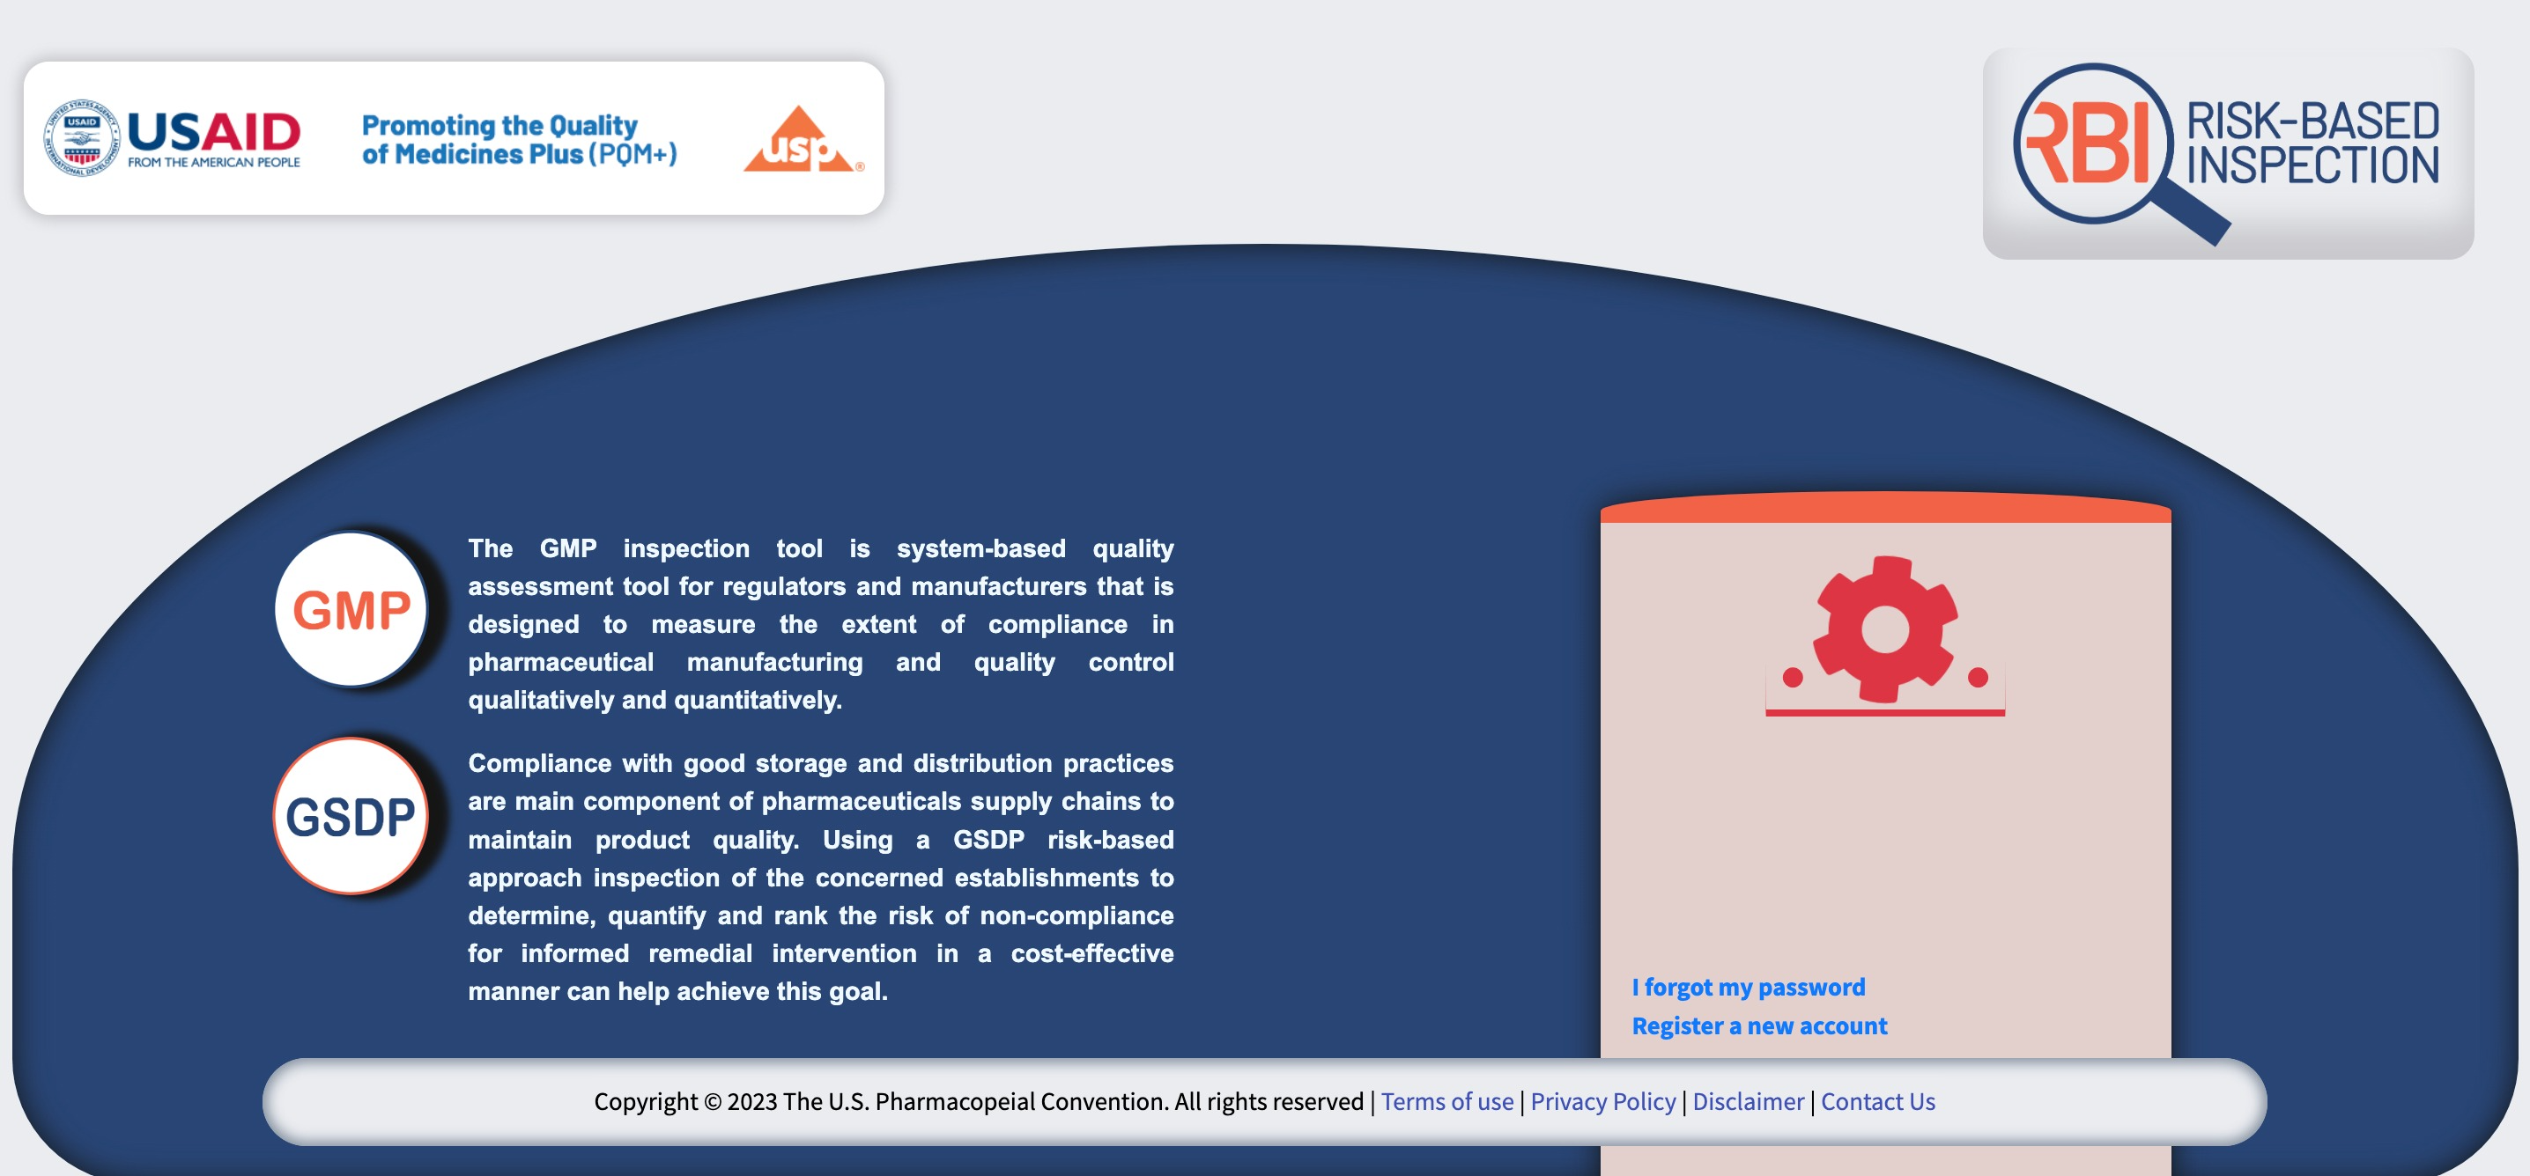
REASON: Super Admin has set the RBI Tool under Maintenance mode to perform system-level maintenance related activities.
Steps to follow: Super Admin will follow these steps:
- Step-1: Login to MySQL /MariaDB on the server
- Step-2: Select the RBI database
- Step-3: Open tbls_System table
- Step-4: Change Status against column Mode with value of Maintenance from Active to Inactive of the second row and save the record as shown below:
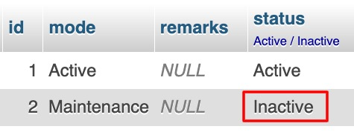
- Step-5: Now refresh the RBI page and it will load the landing page as normal.

- After login, always default profile page is displayed: Whenever user logs-in the RBI Tool since its creation, user always observes the profile page after the login. Why it doesn’t go directly to the Dashboard page of the RBI Tool.
REASON: Since user hasn’t changed his/her password after the first login with the system generated password, RBI Tool always opens the profile page to remind the user to change the password. Once password is changed, user will not see this profile page after login. However, user can change his /her password on any stage by clicking on the profile page as described in the user operational manual.

Steps to follow: User will follow these steps:
- Step-1: From the profile page, input following information:
  - Old Password
  - New Password
  - Confirm New Password
- Step-2: Click on Submit button to save the profile
- Step-3: Next time when you will login to the RBI Tool, you will not see profile page after successful login until or unless you open profile page by yourself.

- What Super Admin should do in Case of disaster & recovery scenario: It’s always recommended to take database backup of the RBI Tool on daily basis as described in the user operational manual. However, application backup should also be taken if there were any modification made in the functionality of the RBI Tool itself. Backup functionality procedure is provided in the System Administrator role as prescribed in the user operational manual.

REASON: Sometime server’s operating system is corrupted because of various reasons, like some virus attach, malware software related activities or by the negligence of the server administrator or because of some natural disaster that corrupts the server of even the database as well. In this case, software will not work as desired.

Steps to follow: User will follow these steps:
- Step-1: Download the latest Application and database Backup files from the following folder:
  - backup
- Step-2: Normally you will see following types of files:
  - RBI_03-Oct-23 23-11-52.zip – (This is application Backup file)
  - RBI_14-Sep-23 00-19-14.gz – (This is database Backup file)
- Step-3: Use these updated files to deploy the RBI Tool application as per the steps provided in the operation manual (deployment section).
Additional glitches that were observed during the internal testing, pilot testing, and post pilot testing should be added to the troubleshooting. Examples include but not limited to;
- Failure of the tool upload files or templates.This includes inspection agenda, adding manufactuers bulk database, inspection docurment, and guidelines
- Reports and/or templates can’t be downloaded
- Error in calculations and/or categorization level
- Mismatch between the column heading and content
- Failure of the tool software system to communicate with the NMRAs admin right after signup for registration.
- Failure of the tool to send inspection notification to the contact person of the company
- Failure of the tool to report the observations under their respective categories; for example, reporting of major observations under critical

